Creative Quilt-works October 2017-Kristin, Ellen, Lynda

Template is for a 1 inch hexi. Cut multiple hexis out of card stock to use as foundation pieces. You may use precut template in cardstock or plastic.

Use foundation to cut out fabric ¼ inch larger than hexi. This can be cut out of a 2.5 inch square, or any scrap fabric. Fold over scant ¼ inch. Use a running stitch to secure or a glue stick and attach hexis together.

Your Challenge should you chose to accept it is to: Create a small bag or box or ornament to bring to the November meeting for a peer review vote. First second and third prize winners will be chosen along with a drawing from the entries for a prize. Get ideas from the internet or each other. I even have a book!

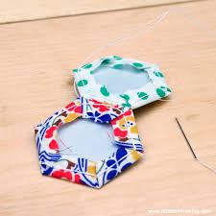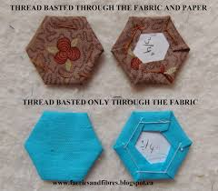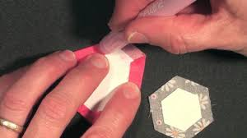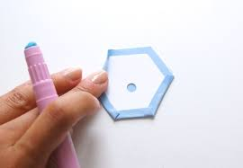

stitch basted baste only through glue basting
fabric not card stock

