Hammersmith Quilters Guild Newsletter

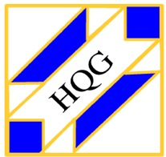

www.hqgsaugus.org September 2017

***For This Meeting***
September 6, 2017

Program: Welcome Back; Show ‘n’ Tell: “What I Did Over the Summer”
Show 'n' Tell: Yes
Fat Quarter: Celestial Prints: think stars, suns, moons, planets, etc.

Refreshments: The following members have signed up to bring snacks for the September meeting: Barbara Martinson, Kathy Connors, Lucille McCarthy, Irene Dwyer, Carol MacRae, Louise Nazzaro, and Linda Reppucci. Barbara and Kathy ask that if you have not yet signed up to bring a snack to a meeting, please do so at the September meeting. Barbara will have the sign-up list available and will leave a copy at the snack table.

Welcome to our new slate of officers, who officially assumed their duties on July 1st:
President: Martha Mazeika
Vice President: Gail Dwyer
Secretary: Dottie Macomber
Treasurer: Carmen Arnone
Program Chair: Julie Legere
Member-at-Large: Sally Nimblett

The following have volunteered to head our various committees:
Merle Gordon, our new Hospitality Committee
Kristin Callahan, Creative Quiltworks
Charity Donations, Gretchen Berkowitch
Refreshments, Barbara Martinson

The following people have also volunteered to assist with various committees and activities:

Program: Paula Grenier
Hospitality: Adrienne Nolan
Creative Quiltworks: Ellen Moore & Lynda Garniss
Charity Donations: Louise Nazzaro & Sally Nimblett
Refreshments: Kathy Connors
Fat Quarter Drawing: Barbara Adler & Linda Gauthier
Name Badge Drawing: Margarita Blyumkina & Gerry McCaul
3 for $1 Raffle: Linda Anthony & Lesley Pew

If anyone would like to help with any of these committees, please see the chairperson of that committee or speak to President Martha Mazeika. Many hands make light work, so you are invited to get involved, meet and work with fellow guild members, and help in making your guild a well-run and fun organization. It’s a terrific way to meet new people, and you’ll feel good because you are helping your guild.

President’s Message
Greetings from your president!
I hope you have all had a good summer, and welcome to the new year for the Hammersmith Quilters Guild. I am excited for the meetings to start, conversations to be a part of, the sharing to commence, and the learning to happen!
The executive board met on August 8th. We have set a theme for the year - "Voices of the Hammersmith Quilters Guild". With this theme, we want to call on the guild members to share their quilting knowledge, we want members to be a part of the guild, we want you to share your expertise, we will ask for simple feedback on your experience as a part of the HQG, and most importantly we want you to be heard. We are excited to work and share with you all.
I have a couple of exercises planned for the September Guild meeting to start to hear from you. I also want you to feel free to talk with me at meetings, via phone, or email. I am here to try to make your experience as a guild member great.
I look forward to working with you all. Always here to listen, talk, discuss, and answer questions.
See you all on September 6th!
Martha Mazeika
(413)250-5449
marthamazeika@gmail.com

Volunteer Opportunity

American Quilt Study Group (AQSG) Annual Seminar is at the Radisson in Manchester, NH October 18th to October 22nd. Volunteers are needed!

The American Quilt Study Group (AQSG) is an international organization of quilt enthusiasts and historians and membership is open to all lovers of quilts and their history. Seminar features classes, tours, special quilt exhibits, and lectures. The organization seeks local volunteers to help with registration, tours, and fund-raising auctions.

Volunteer benefits:
- Invitation to attend the presentation of research papers on Saturday and Sunday morning (meals not included.)
- Invitation to visit the on-site exhibits, Vendor Sale, Author’s Book Sale, and participate in the Silent and Live Auctions by securing a bid number.
- Cost for tours is complimentary for volunteer tour leaders excepting lunch.
I am a long-time member of AQSG and can provide more information about volunteering at Seminar. Please don’t hesitate to contact me. You can go online to find more information about AQSG at: americanquiltstudygroup.org

Martha Mazeika
(413)250-5449
marthamazeika@gmail.org

Vice President’s Message
As your new vice president, I am looking forward to a fun-filled year with the guild and helping
our wonderful new president, Martha Mazeika. Please feel free to come to me anytime with
any concerns or ideas!

Sincerely,
Gail Dwyer

Treasurer’s Report
According to the bylaws, as your newly elected treasurer, I am "Custodian of the Guild's assets". Fortunately, Anne Smith, our former treasurer, has kept excellent records and has been most helpful with my transition. I am also responsible for deposits and disbursement of Guild funds and will give a brief report at each meeting as well as a more detailed printed report to Executive Board members.
I will be following the same policy Anne has used regarding refunds of monies you may have incurred related to your committee duties. Please submit your receipt(s) to me at guild meetings. If possible, I will write a check and reimburse you then and there. If not, I will mail the check to you ASAP.
Bottom line: no receipt, no refund!
Please feel free to talk with me if you have any issues or concerns regarding my duties.
Carmen Arnone

As of August 1, 2017, we had $14, 425.63 in our treasury.

Membership
Dues: Your dues for the 2017-2018 guild year were due by the June meeting. Regular dues are $30 and senior dues for age 70 and up are $25. You may pay by cash or by check made out to HQG or Hammersmith Quilters Guild. If you did not pay your dues at the June meeting or over the summer, please bring payment to the September meeting.

Sally Nimblett will have membership cards for 2017-2018 for those who have paid their dues. She is also asking everyone to check their contact information against the membership list she will have at the front table; you can do this when you sign in.

Program Committee
Julie Legere and her committee have an exciting year of speakers, workshops, and other programs planned for you! Information about some of the upcoming speakers, as well as the annual getaway weekend, will be shared at the September meeting.

If anyone knows of halls or other spaces that might be available for the guild to rent for workshops involving large groups, with space for at least 10 or 12 members, please notify a member of the Executive Board. Such a space would need to be accessible (no steps) and have adequate electrical outlets for multiple sewing machines, irons and lights. We have tried a few venues in the area in the past few years but some have inadequate electrical capacity, limited availability and/or are too expensive. We need your help to find some good spaces for workshops and Saturday Sew-Days.

Charity Donations Committee
Gretchen Berkowitch would like to remind everyone that we are again collecting pillowcases and quilts for various organizations. We will be making holiday pillowcases again, stuffing them with gifts, so it’s not too early to think about getting out your winter or Christmas-themed fabric and starting the holiday pillowcases. If you make a holiday pillowcase, that counts as your suggested donation for pillowcases. (You are most welcome to make more than one, as some members always do!) Donated quilts in any size are accepted; we need baby quilts to lap quilts to twin-size quilts. Your donated quilt does not have to be elaborate or intricately-pieced; grab a cute preprinted panel, add some borders (or not!) and you have a great little quilt! Panels are a perfect place to practice your free-motion quilting, but you can also just quilt a grid using your machine’s walking foot. Anything goes! You will feel good in the knowledge that your donation will make some child, some preemie baby’s parents, some Camp Erin camper or some other worthy recipient, very happy.

Last year we donated a total of 222 pillowcases and 74 quilts. Let’s keep up the pace and meet or exceed that number!

Creative Quiltworks Committee
Our new CQW chairperson, Kristin Callahan has a fun new challenge for September. She will explain the details at the meeting and will have handouts available. No need to sign up in advance, just participate if you want to. The finished project will be due at the October meeting, and Kristin will have some incentives to encourage you to participate! (Just a little hint about the project: it involves yo-yos – and I don’t mean the Duncan-on-a-string kind!)

Minutes of Previous Meetings
The Executive Board held its first meeting on Tuesday, August 8, 2017 at Panera in Saugus. Members of the board decided on a theme for this guild year, “Voices of the Hammersmith Quilters Guild” and discussed ways to help members be involved with the guild. They reviewed their duties according to the guild bylaws, as well as the duties of the various committees. The programs for the guild year were presented and discussed, including a new format for some workshops that involves holding workshops for smaller groups at a member’s house, thereby eliminating the need to rent a hall. The board began a discussion of the annual budget but will continue this discussion at a subsequent meeting.

A printed report containing the full minutes of the meeting will be available for your perusal at monthly guild meetings; see Dottie if you would like to review this report.

Member News
Linda Anthony had done it again! She has another pattern published in “The Quilt Pattern Magazine”, a monthly online magazine. Her new pattern is “Scrap-It-Up, Row-a-Month Quilt”, an eleven-part row quilt that will be running from August 2017 through the June 2018 issue. This quilt is made almost entirely with scraps from your scrap basket or bin (or, in my case, a very large Rubbermaid tub!); Linda also makes suggestions for using precuts if you do not yet have a stash of scraps.

You can subscribe to The Quilt Pattern Magazine at www.quiltpatternmagazine.com Because Linda is a contributor to the magazine, they have given her a “secret” code for our guild members to use to get a discount on a one-year subscription. The code is HQG.

Janet Dalis had a quilt accepted into the “World Quilt New England” Mancuso show in Manchester, NH (August 17-19, 2017). As of press time, we do not know how Janet made out with the judging, but I hope we will hear at the September meeting. Here is Janet’s description of her quilt, which is shown below from both the front and the back of this quilt-as-you-go quilt:

“The Splendid Sampler Sew Along with Pat Sloan, Jane Davidson, and 85 designers around the world, began in February 2016 and finished in February 2017. I redesigned several blocks in consideration of the Reproduction fabrics I chose to work with; otherwise, I followed the patterns provided. It was an opportunity to try new techniques. The sashing and the borders were also my design additions. I used the QAYG method, adding the borders after the blocks were sashed and quilted together. It took 18 months to make, start to finish.”

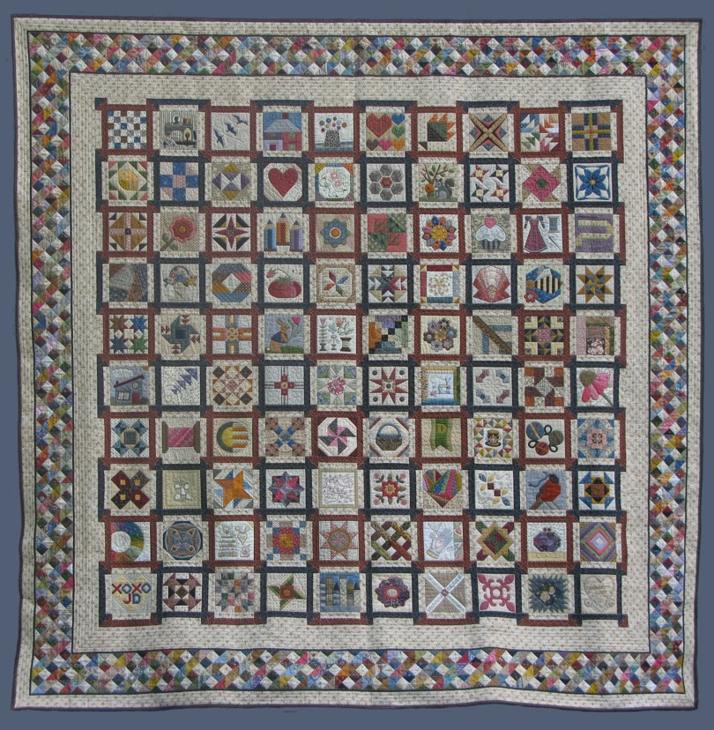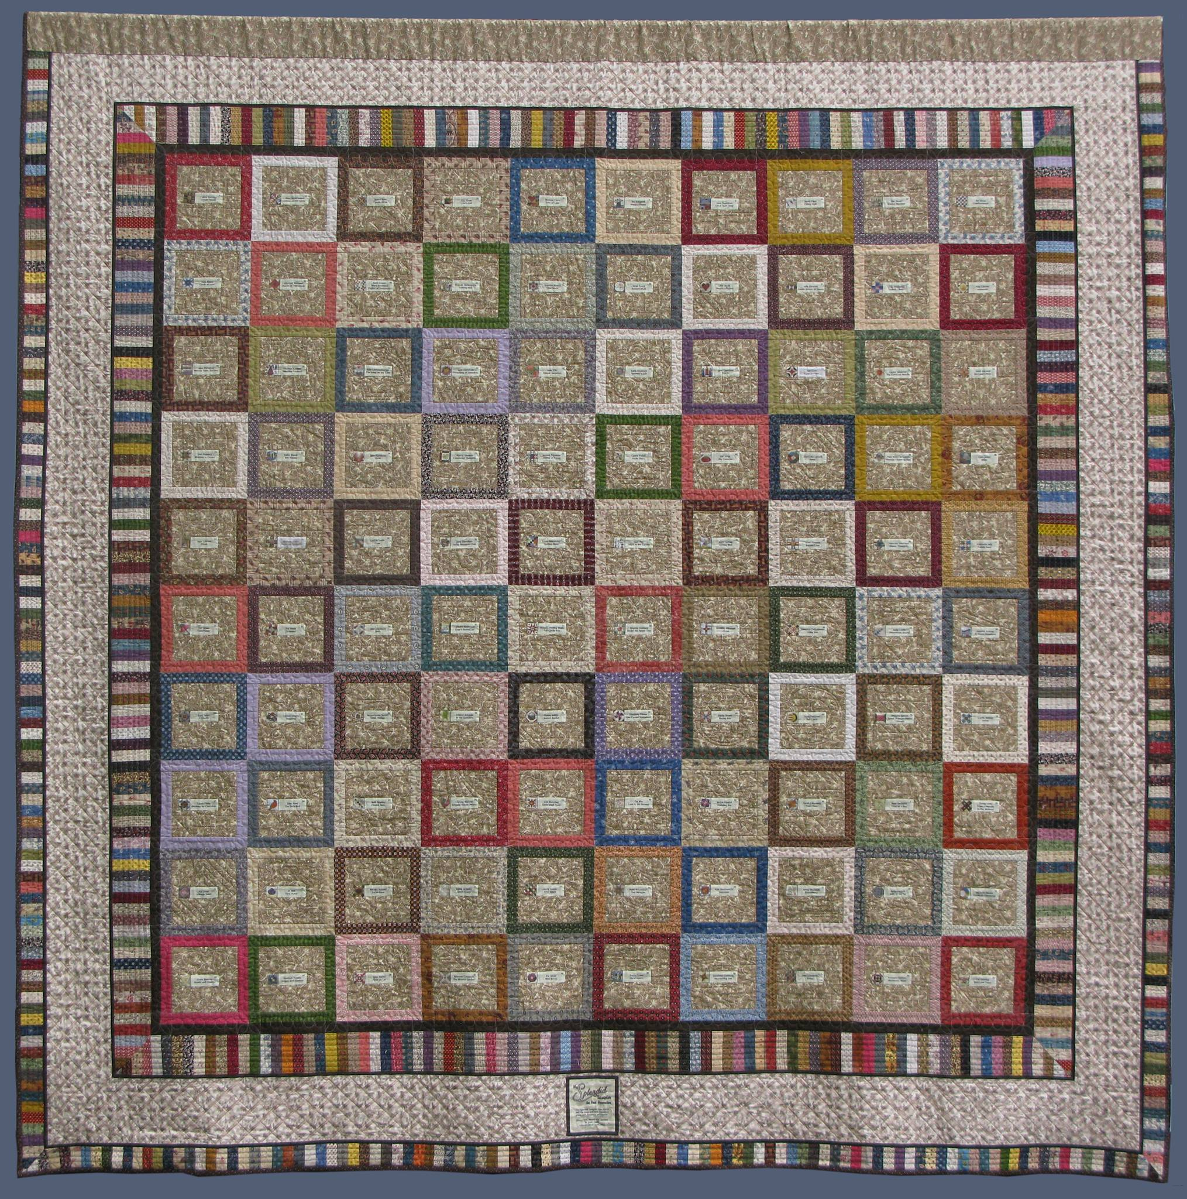

If anyone else submits quilts to shows or fairs, or if you have any other quilty accomplishments to report, please send the news (with photos if possible) to me, Dottie Macomber, at mcandmac@comcast.net or 9 Fletcher Rd, Woburn, MA 01801. Let us celebrate your quilty news with you!

Respectfully submitted,
Dottie Macomber, Secretary

