2018 Raffle Quilt Square
Your Color Swatch!
HQG’s Gridlock

Complete Your Block!

- Complete a 6 ½ inch square block (this includes the seam allowances)
- Your block can focus on a different shape such as crosses, triangles, stripes, squares, haikus
  - Samples of each shape are on the HQG website
  - Link: http://www.hqgsaugus.org/
- Follow the color of the swatch attached
  - 50%-75% of the block should match this swatch

Block(s) are due at the February Guild Meeting (February 7, 2018)
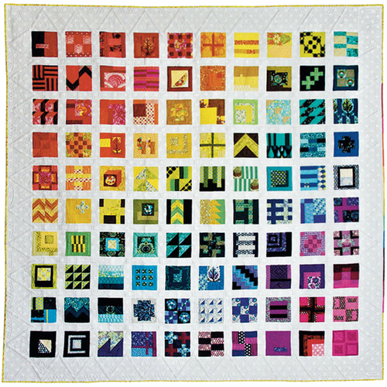
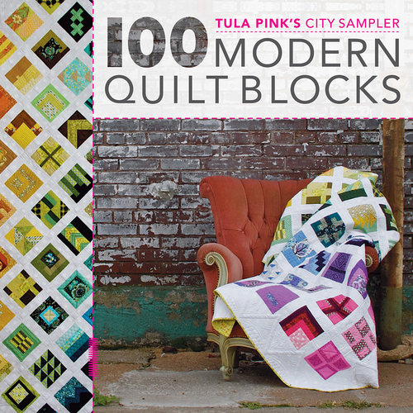
Book by Tula Pink used to inspire the raffle quilt. We are using Tula Pink’s “Gridlock” to create “HQG Gridlock”

