Hammersmith Quilters Guild Newsletter

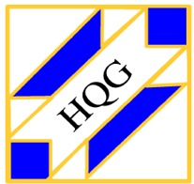

www.hqgsaugus.org October 2017

***For This Meeting***
October 4, 2017

Program: “What Remains: Wooden Quilt Sculptures” by Laura Petrovich-Cheney
This exhibit currently at the Fuller Craft Museum in Brockton features the scrap “quilts” of New Jersey artist Laura Petrovich-Cheney. Using traditional and contemporary quilt patterns, Laura creates complex and vibrant forms from Hurricane Sandy debris that was salvaged by the artist from dumpsters, refuse piles and local waste stations. This body of work explores issues of loss, identity, memory, and renewal. Guest fee for this meeting is $10.

Show 'n' Tell: No

Fat Quarter: Yellow

Refreshments: The following members have signed up to bring snacks for the October meeting: Joyce Rodenhiser, Joan Fowler, Jeannie Bartolo, Jane Amato, Denise Moran, Ann Ambrose, Lorraine DiMilla, Ruth Cameron, Heidi August, and Donna Cormier (who will bring water on months she attends). Barbara and Kathy ask that if you have not yet signed up to bring a snack to a meeting, please do so. Barbara will have the sign-up list available and will leave a copy at the snack table.

Creative Quiltworks: If you made a yo-yo project, be sure to bring it to this meeting. See below.

President’s Message: Martha Mazeika
Greetings from your president!
Fall is upon us. For me it starts the season of hiding out in my quilting room to work on projects.
The September meeting was great. I want to thank those who shared their quilts with us during the Show & Tell.
Thank you to all who added responses to the questions posted. According to your answers, we come together as a guild to socialize; for inspiration, learning, and show & tell; and to hear speakers. I am pleased that we have a few guild members who would like to participate in a trunk show or to share his/her skills. There were a couple requests to learn how to do presentations as well. Hopefully we can organize a program around this. Your responses about what you would like to experience are the following: new and easy techniques; how to critique each other’s quilts; road trips; and mystery trips. We have multiple ways to share our stories and hear each other’s voices. It is going to be a great year.
I am looking forward to our speaker, Laura Petrovich-Cheney, in October. I reviewed some of her wooden quilt sculptures on her website. I enjoy admiring what artists do when they rework old and/or used materials. I have not seen wooden quilts so this is going to be interesting!
Always here to listen, talk, discuss, and answer questions.
See you all on October 4th!
Martha
(413)250-5449
marthamazeika@gmail.com

Volunteer Opportunity

American Quilt Study Group (AQSG) Annual Seminar is at the Radisson in Manchester, NH October 18th to October 22nd. Volunteers are needed!

The American Quilt Study Group (AQSG) is an international organization of quilt enthusiasts and historians and membership is open to all lovers of quilts and their history. Seminar features classes, tours, special quilt exhibits, and lectures. The organization seeks local volunteers to help with registration, tours, and fund-raising auctions.

Volunteer benefits:
- Invitation to attend the presentation of research papers on Saturday and Sunday morning (meals not included.)
- Invitation to visit the on-site exhibits, Vendor Sale, Author’s Book Sale, and participate in the Silent and Live Auctions by securing a bid number.
- Cost for tours is complimentary for volunteer tour leaders excepting lunch.

I am a long-time member of AQSG and can provide more information about volunteering at Seminar. Please don’t hesitate to contact me. You can go online to find more information about AQSG at: americanquiltstudygroup.org

Martha Mazeika
(413)250-5449
marthamazeika@gmail.org

Treasurer’s Report: Carmen Arnone
As of September 11, 2017, we had $14, 720.45 in our treasury.
Just a reminder: if you make purchases on behalf of the guild, please submit your receipt(s) to me at guild meetings. If possible, I will write a check and reimburse you then and there. If not, I will mail the check to you ASAP. Bottom line: no receipt, no reimbursement!

Membership: Sally Nimblett
Dues: Your dues for the 2017-2018 guild year were due by the June meeting. Regular dues are $30 and senior dues for age 70 and up are $25. You may pay by cash or by check made out to HQG or Hammersmith Quilters Guild. If you did not pay your dues at the June meeting or over the summer, please bring payment to the October meeting or mail your check to me.

Seventy-five people signed in at the September meeting- great attendance! I’m sure there were more, as there were already folks there by the time I got there at 6:15. If you arrive before I do, please be sure to circle back to the front table later and sign in. We like to keep attendance records for the following reasons: it helps us to know which programs/months are the most popular; and it give us an idea of how many handouts to prepare for meetings.

Program Committee: Julie Legere
Just a reminder about the possible workshop with Nancy Turbitt in November. She will be our speaker at our November 1st meeting and, if there is enough interest, she will teach at workshop the next day on enhancing quilts with fabric markers. The workshop will be from 9 a.m. to 4 p.m. on Thursday, November 2nd. We will probably send out for lunch. Cocktails start promptly at 4:15 p.m.

I need to have a definite headcount by the end of the October guild meeting so I will know if it will be cost-effective to offer this workshop. Signups will be at the October 4th meeting, and a nonrefundable deposit of $20 will be due at that time. The exact final cost will be determined once I know how many people are signing up. The workshop will be at my house in Saugus, and the maximum number of participants is 15. Nancy charges $550 for the workshop and, because only a small number of guild members can participate, the guild will not be subsidizing this workshop. Therefore, Nancy’s fee will be split evenly by the participants. If we get the maximum of 15 participants, each will have to pay approximately $37, which is a very reasonable price for an all-day workshop. If you have friends who are not guild members but who would like to take this workshop, let me know in October and, if we have not reached the 15-person limit, we would welcome your friends in this workshop. Be prepared to bring their $20 deposit to the October meeting and give me their name and contact information.

**********************************************************************************************************************

Deposits for the Getaway weekend at the Ramada Inn and Conference Center in Saco, Maine, on March 23-25, 2018 will be collected beginning at the October 4th meeting. There will be a non-refundable deposit of $50. Make out your checks to Hammersmith Quilters Guild or HQG. More information on the final cost will follow soon. As was the case last year, there will be an option to add Thursday night to your stay.

A member asked if we could consider something different for this next getaway: are there any members who will be attending who would like to present a class at the getaway? If someone is interested in doing this, speak to Julie or Dottie. We can make this as simple or as elaborate as you want. We have had short demos at past getaways as well as mystery quilt projects. While many people go on the getaway just to work on their own projects, some people may be interested in taking a short class. If you have an idea, let us know! You would need to provide a supply list for your class or project and, if it involves handouts or other materials that people would need to pay for, you would need to do signups and let people know all this ahead of time.

**********************************************************************************************************************

If anyone knows of halls or other spaces that might be available for the guild to rent for workshops involving large groups, with space for at least 10 or 12 members, please notify a member of the Executive Board. Such a space would need to be accessible (no steps) and have adequate electrical outlets for multiple sewing machines, irons and lights. We have tried a few venues in the area in the past few years but some have inadequate electrical capacity, limited availability and/or are too expensive. We need your help to find some good spaces for workshops and possible Saturday Sew-Days.

Charity Donations Committee: Gretchen Berkowitch, Sally Nimblett & Louise Nazzaro
1. In lieu of stockings, HOLIDAY THEMED PILLOWCASES will be collected at the October and November meetings. Pillowcases should have winter or winter-holiday fabrics. They will be stuffed with any children’s quilts we receive at the October and November meetings as well as any gift items that are donated.

2. A poster listing suggested age-appropriate gift items will be available at the October meeting. Please look over the poster and take a sticky-note to remind you of the items that you would like to donate. (These items include such things as school supplies, hats, gloves, mittens, books, coloring books, and small toys.) These items should be brought to the November guild meeting, as we will be stuffing the pillowcases later in November for delivery to various social service agencies in early December.

3. The pattern for “magic” pillowcases (also called Sausage/Burrito/Tube pillowcases) is available on Pinterest. New members should have received a pattern in their welcome packet. If anyone needs a pattern, please contact Sally Nimblett or Dottie Macomber.

4. Thank you to all members who made hurricane donations of pillowcases, quilts and other bedding. Our donations will either go to Harvey or Irma survivors. The Watertown Fire and Police will be coordinating with the Red Cross to determine need. YORK Kia in Medford was grateful for our contributions.
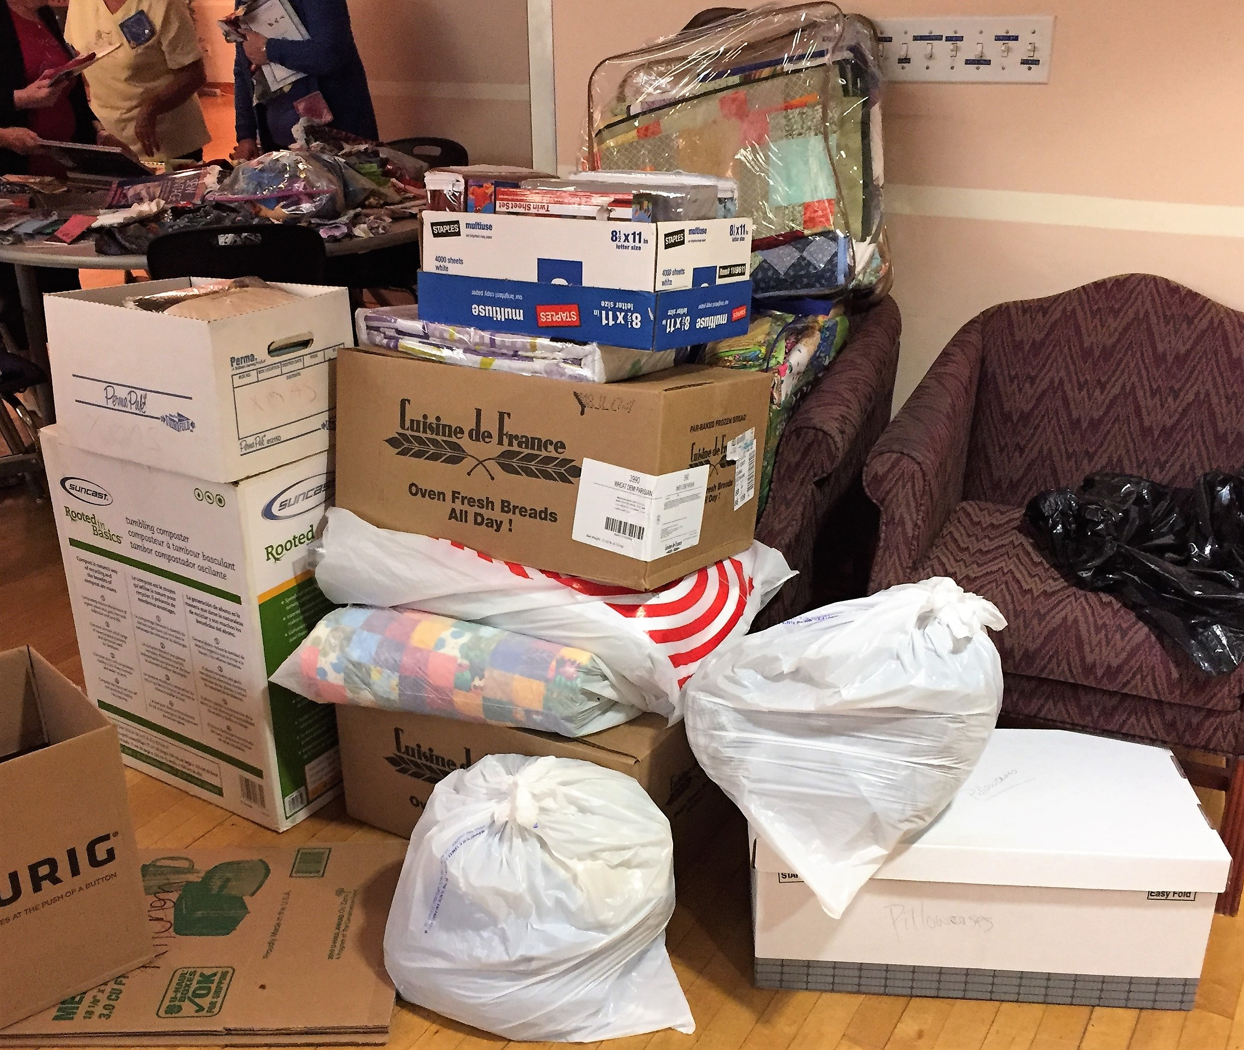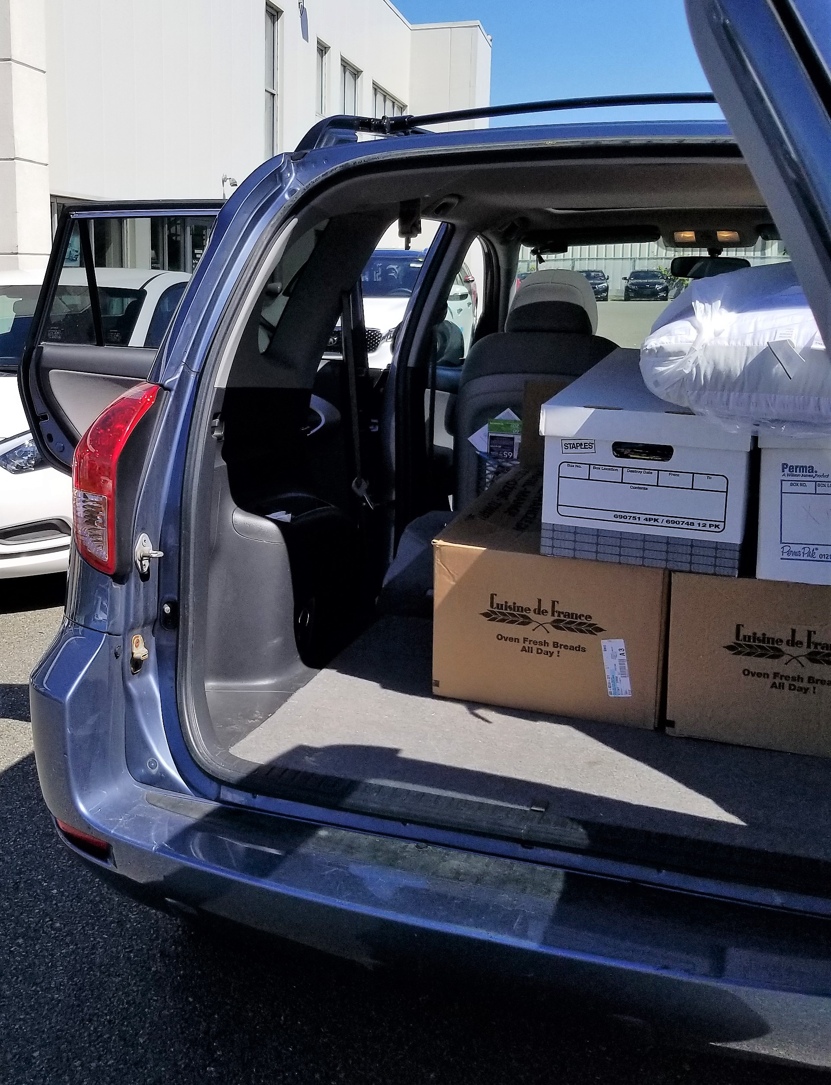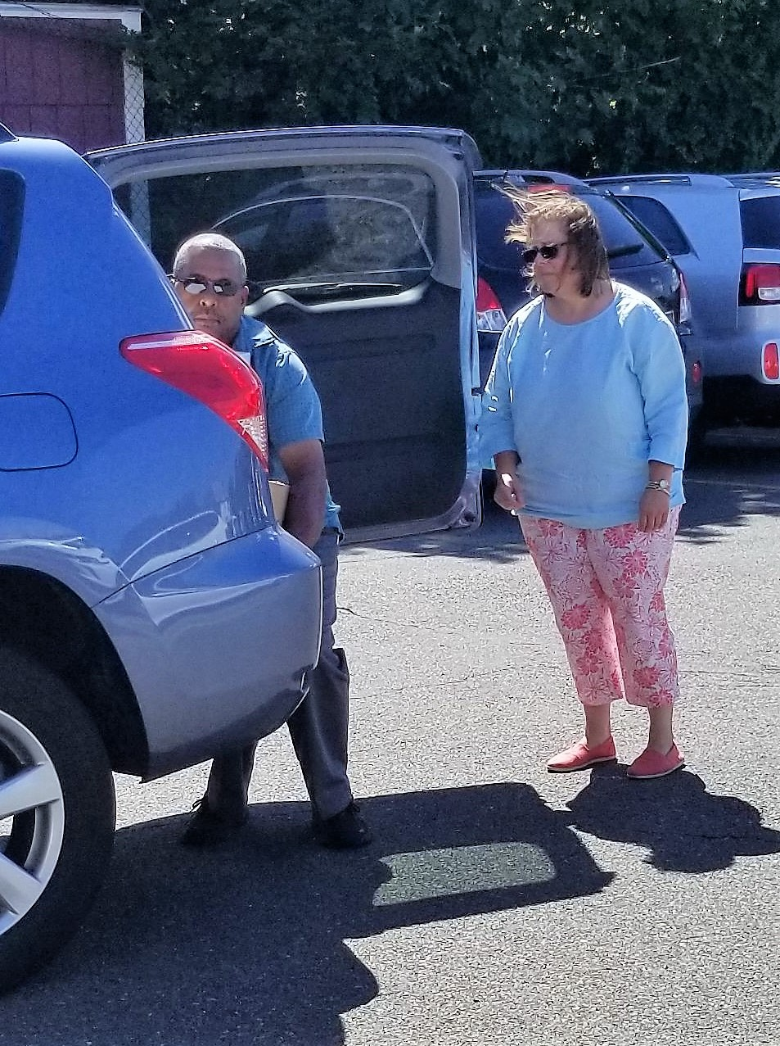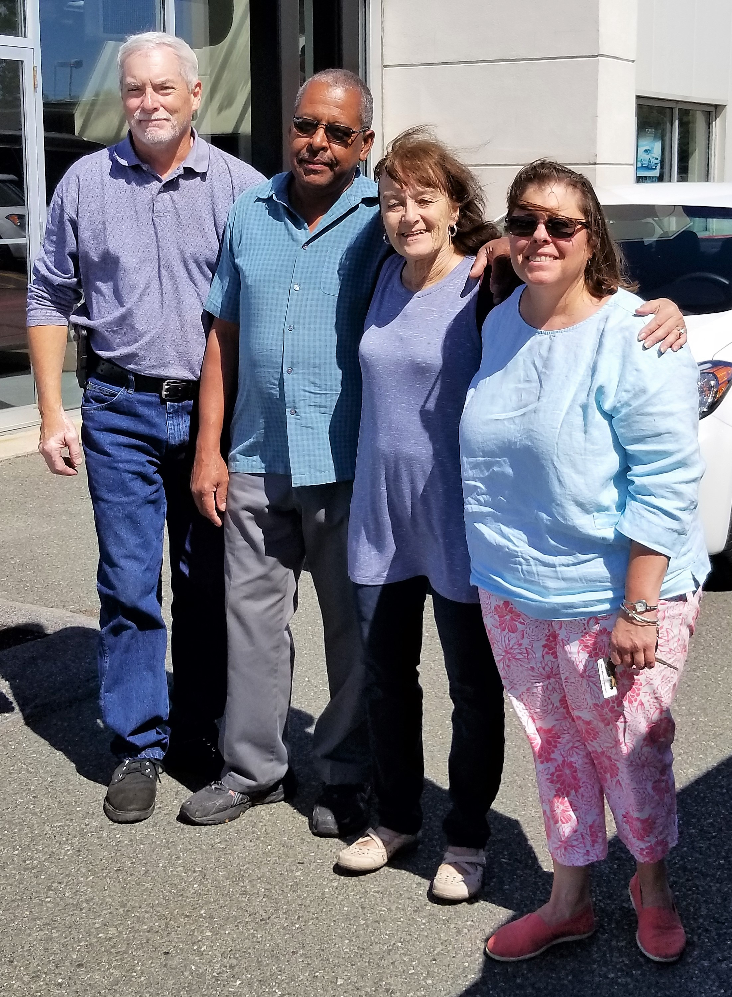

Donations collected at our September meeting, unloading the car at York Kia, Gretchen and York Kia employees

Creative Quiltworks Committee: Kristin Callahan, Ellen Moore & Lynda Garniss
Please bring in your yo-yo project and place it on our table for the vote during the meeting’s break. You will be given a number for your entry and a raffle ticket.

Everyone is eligible to vote, but only entrants will be eligible for ribbons or the raffle prize.
There will be ribbons for 1st, 2nd and 3rd place, and one winner will be chosen randomly from all entrants to receive a prize!

Please pick up directions for the next project from Ellen, Lynda or me. I will also have extra copies of the yo-yo directions in case anyone missed the September meeting and would like these directions. The directions for yo-yos are also available on the guild website under the Newsletter tab.

Kristin

Quilt Show Committee: Martha Mazeika & Linda Reppucci
Martha and Linda have been busy reviewing the documents from past shows. We asked around last year for ideas for the raffle quilt. John Balliro suggested Tula Pink’s City Sampler – Gridlock. We have 2 options for the color scheme, rainbow and color to white. An email will be sent to you all with a link to a survey to choose the color design and submit your name if you would like to be part of the committee to work on the 2018 Raffle Quilt. You will also have an opportunity to sign up for other committees for the quilt show. The survey and quilt show committee signup information will be mailed to those members without email.
We will have more information at the October meeting!
Happy Stitching!
Martha & Linda
2018 Quilt Show Chairs

Minutes of Previous Meetings: Dottie Macomber
At our September 6th meeting, new officers and committee members were introduced, officers spoke briefly, and committee chairs gave reports on the functioning of their committees. The theme for this year, “Voices of the Hammersmith Quilters Guild”, was introduced and members had the opportunity to answer questions to help enhance their enjoyment of and participation in the guild.

Programs and workshops for the next couple of months were presented, as was information about the guild Getaway Weekend in March 2018. Charity projects, including those for hurricane victims and our annual pillowcase “stuffing”, were discussed.

The usual snack and socialize break occurred, and an extended Show ‘n’ Tell delighted everyone, as we got to see what others had done over the summer break.

A printed report containing the full minutes of the meeting will be available for your perusal at monthly guild meetings; see Dottie if you would like to review this report.

Member News: Dottie Macomber
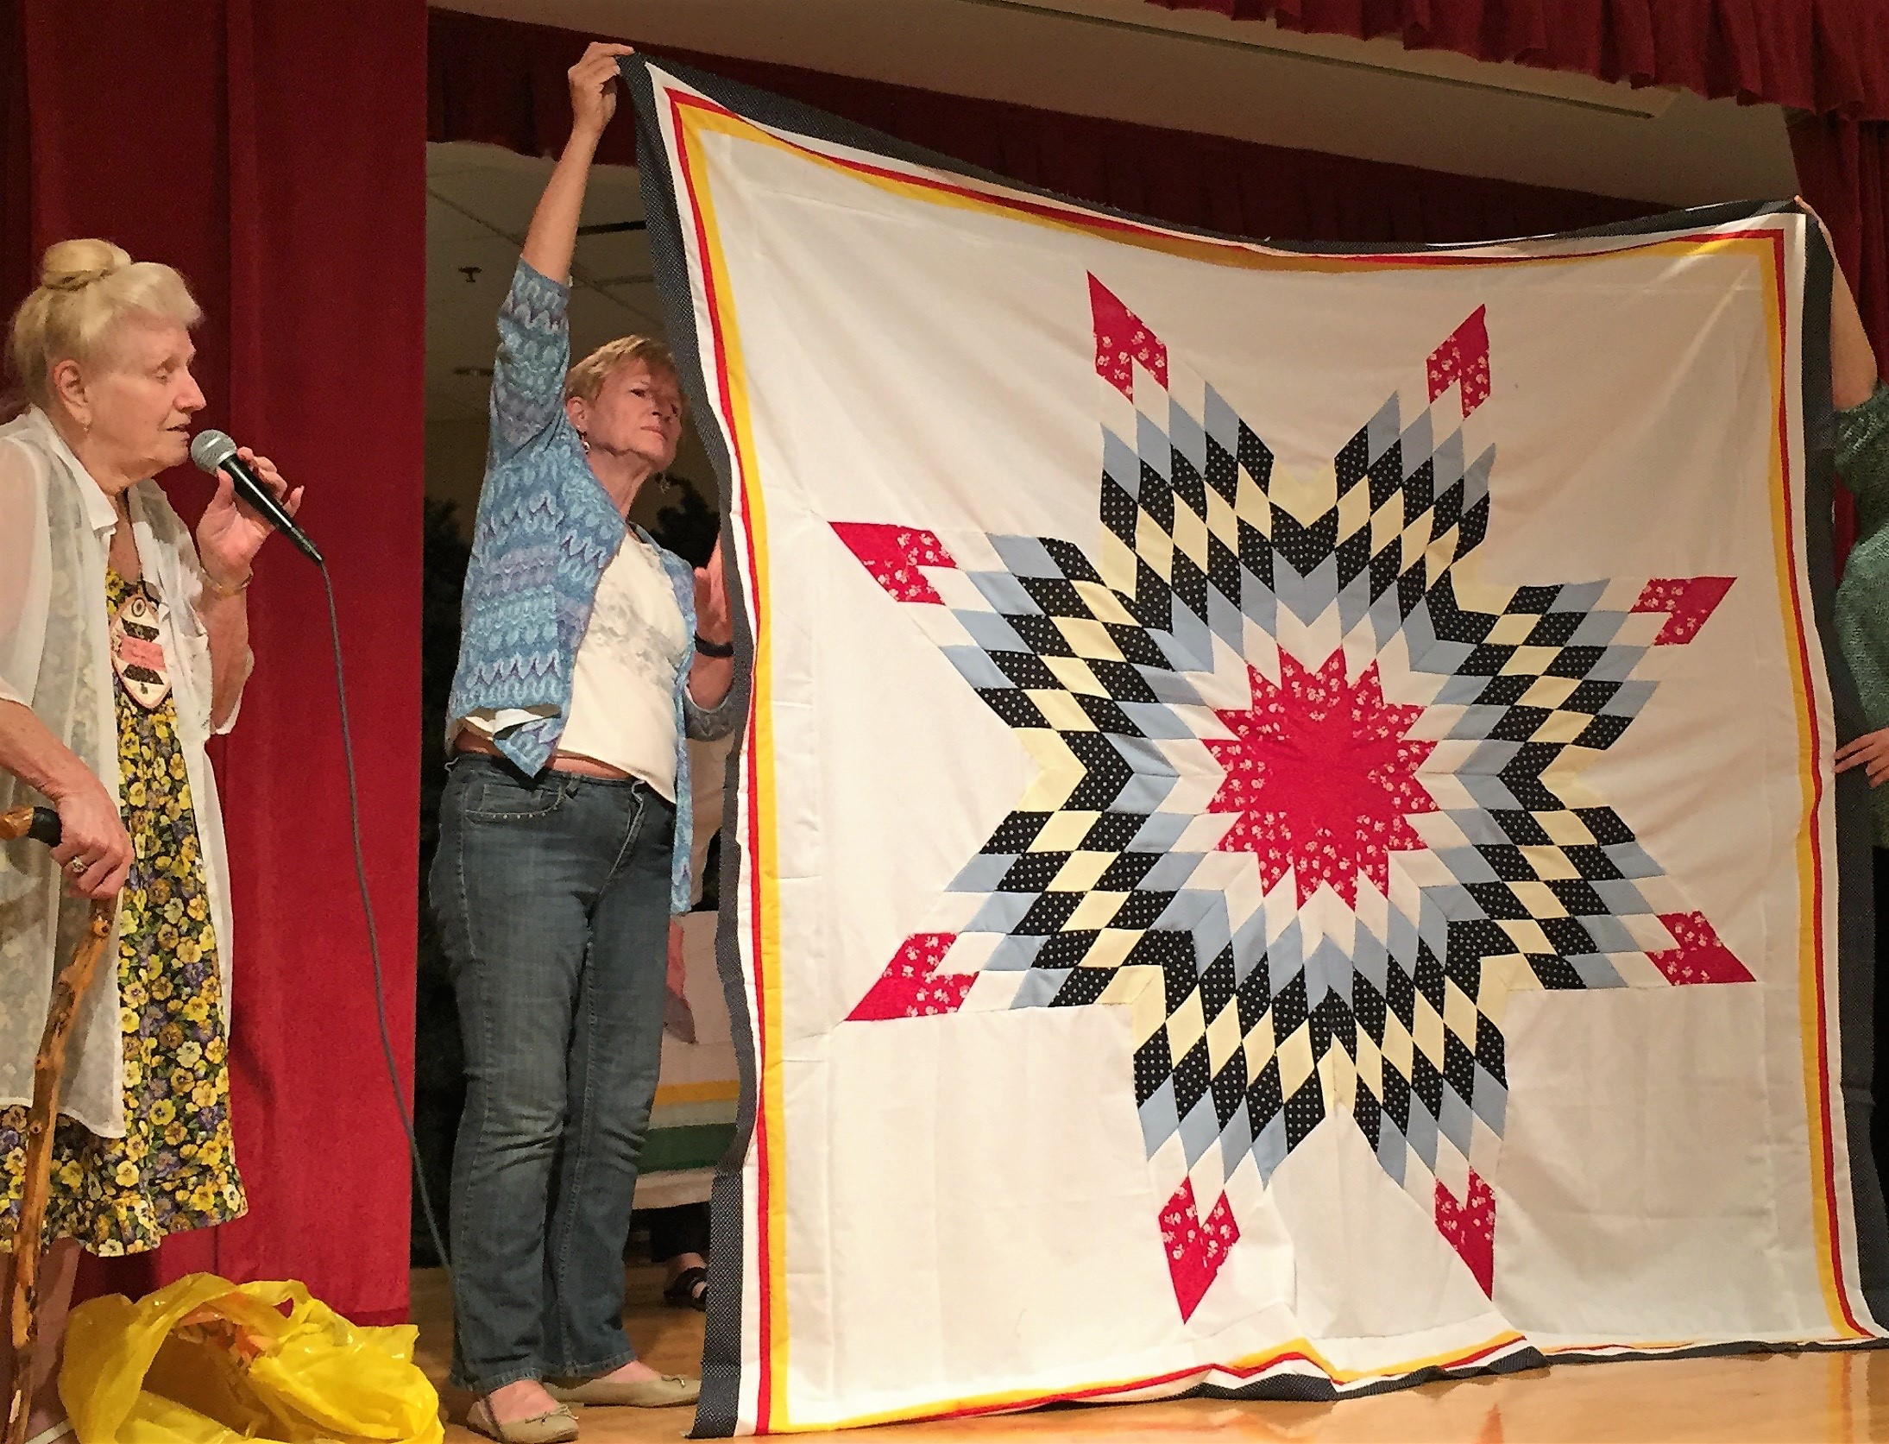

Ruth Ruggeri and the all hand-pieced Lone Star quilt she made and donated for Quilts of Valor- Thank you, Ruth! And remember, Merle Gordon is our liaison to the regional coordinator of Quilts of Valor, Darlene Coit, and will accept quilt blocks and tops any time to turn in to Darlene. You do not need to use red, white and blue or patriotic fabrics or star patterns, but these are often the most popular ones chosen by service members.

Note: I attended the Squanicook Colonial Quilt Guild’s show on September 17 and ran into Darlene, who had a table there where she was explaining the Quilts of Valor program to visitors, just as she did at our November 2016 quilt show. She mentioned that Merle had delivered Ruth’s quilt, as well as a quilt that Julie Legere had machine-quilted for Quilts of Valor. She remarked on the beauty of both quilts and was very grateful for our ongoing efforts to cover veterans with love and appreciation.

*********************************************************************************************************************

If you have access to the internet, be sure to see our website for other photos from September’s
Show ‘n’ Tell.

*********************************************************************************************************************

Former Member Carole Blois has not been able to rejoin the guild due to health issues. I am sure she would appreciate hearing from her Hammersmith friends. Carole’s address is 63 Altamount Ave., Saugus, MA 01906.

*********************************************************************************************************************

If anyone submits quilts to shows or fairs, or if you have any other quilty accomplishments to report, please send the news (with photos if possible) to me, Dottie Macomber, at mcandmac@comcast.net or 9 Fletcher Rd, Woburn, MA 01801. Let us celebrate your quilty news with you!

Respectfully submitted,
Dottie Macomber, Secretary

