Hammersmith Quilters Guild Newsletter

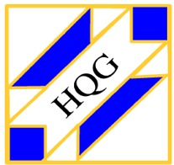

www.hqgsaugus.org May 2018

***For This Meeting***
May 2, 2018

Program: Speaker: Pam Weeks, Curator at the New England Quilt Museum

Let your friends know about this program; the guest fee is $10.

Show 'n' Tell: No

Fat Quarter: Batiks

Refreshments: Lynda Galvin, Lesley Pew, Adrienne Nolan, Carole Prodanas, Rebecca Mohammadi, Sheila Darcy, Kathy Boardman, Ellen Moore, Ann Kelly-Maguire, Donna Cormier (water)

Creative Quiltworks: Continuous Prairie Points project

President’s Message: Martha Mazeika
Greetings!!

Quilters Home magazine published “The Quilters Home Bill of Rights” in the July/August 2007 issue. I want to share with you these rights over the next few months as stated in the article:

- A quilter has the right to the establishment of quilting guilds or other quilt-related groups.
- A quilter has the right to store their fabric any way they want and not organize it by color, type, or size.
- A quilter has the right to chat with their fellow quilters even if they are supposed to be working.

We are making up the missed meetings on July 11th and August 8th. These meetings will be part of this current year. The 2018/2019 year will start in September 2018. Programs for these meetings have not been planned. Once we know the plan for those meetings we will let you know.

Thank you to Joyce and Janice who have volunteered to be the new co-chairs for the Program committee. They will start to plan next year’s programs. If you would like to assist with this committee, please let us know.

Always here to listen, talk, discuss, and answer questions.
See you all on May 2nd!!

Martha
(413)250-5449
marthamazeika@gmail.com

Reminder of schedule for monthly meetings:

6:30pm Hall opens
7:00pm-7:30pm Business meeting and Raffles
7:45pm-8:45pm Speaker/Other Program/Show ‘n’ Tell (when applicable)
8:45pm-9:00pm Good byes and Clean up
Please clean your tables, throw away trash, and pick up your snack containers at the end of the meeting.

Vice President’s Message: Gail Dwyer
When you bring in a fat quarter for the monthly fat quarter drawing, please bring in an extra one. This will be for our famous and wildly popular raffle basket loaded with fat quarters, one of the most sought-after raffle baskets at our quilt show! Please make sure that your fat quarter is good quality, 100% cotton quilting fabric. For these fat quarters, any color or theme will be welcome; it doesn’t have to be the same as the fat quarter drawing of the month.

You may give the extra fat quarter to Adrienne Nolan, who is in charge of the raffle baskets for this show.

Treasurer’s Report: Carmen Arnone
Our working balance is $12,242.80
All our bills are paid to date including rent, website, our getaway in March, Allison Wilbur’s lecture as well as the deposit for the 2019 getaway. Members who submitted receipts were reimbursed and we are still solvent!
Just a reminder: if you make purchases on behalf of the guild, please submit your receipt(s) to me at guild meetings. If possible, I will write a check and reimburse you then and there. If not, I will mail the check to you ASAP. Remember: no receipt, no reimbursement!

Membership: Sally Nimblett
Welcome to our four new members who joined in April: Elaine Cobucci, Sandra Morelli, Nancy Kershaw, and Dianne Cheney!! Glad to have you join us! See me next month to get your guild pin and tote bag.

Sixty-five people signed in at the April meeting; there were five guests, four of whom became our newest members!

Dues for the 2018-2019 guild year will be due by the June meeting. The dues are $25 for ages 70 and older, and $30 for all others. I will collect them at the door as you sign in for both the May and June meetings; you may pay by cash or by check made out to HQG. If you will not be at the May or June guild meetings, please mail your dues to Sally Nimblett, 22 Pleasant Park Rd, Winthrop, MA 02152.

Just a reminder to everyone: be sure to sign in each month as you come in, or circle back to the front desk after you have dropped off your “stuff”. We like to keep attendance records because it helps us to know which programs/months are the most popular, and it give us an idea of how many handouts to prepare for meetings.

Refreshment Committee: Barbara Martinson & Kathy Connors
The following people will be bringing snacks for the May meeting: Lynda Galvin, Lesley Pew, Adrienne Nolan, Carole Prodanas, Rebecca Mohammadi, Sheila Darcy, Kathy Boardman, Ellen Moore, Ann Kelly-Maguire, Donna Cormier (water)

Barbara will have a sheet available for folks to sign up to bring snacks in July and August for our “make-up” meetings. Perhaps the folks who were scheduled to bring snacks in February and March could sign up for one of our summer meetings.

New members: see Barbara or find her sign-up sheet at the Snack table to sign up to bring a snack for an upcoming meeting.

Program Committee: Joyce Rodenhiser, Janice Moore & Dottie Macomber
Hooray! A big thanks to Joyce and Janice for signing up to be co-chairs of the Program committee for the next year! They along with Dottie will be planning speakers and other programs for the next guild year.

We on the program committee try to take your feedback into consideration when planning activities. The annual Member Survey, completed by all of you each June, helps us know what you like, don’t like, and would like to see more of, so when it is time to complete this, please take some time to fill it out and include helpful comments and suggestions. We know we can’t make everyone happy, but we try our best!

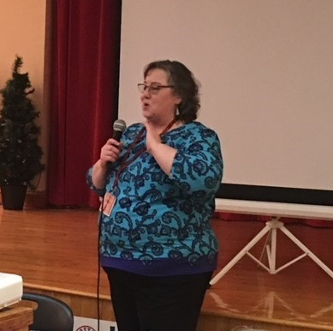
Members at the April meeting thoroughly enjoyed the talk on “Quilting as a Design Element” given by Allison Wilbur (left). She presented ideas for machine quilting that can be done with both longarm and domestic machines.

Our speaker for this month will be Pam Weeks, the Binney Family Curator at the New England Quilt Museum in Lowell. She will be speaking on quilt myths and other fascinating quilt facts and topics.

Charity Donations Committee: Gretchen Berkowitch, Sally Nimblett & Louise Nazzaro
Just a reminder: we are always collecting quilts (any size) and pillowcases to be donated to various charities, and this year we are also collecting doll quilts (sized approximately 16” x 20”) to be sold at our quilt show as a guild fund raiser. These can be brought to any guild meeting. If you have any questions about these items, contact any member of this committee.

Creative Quiltworks Committee: Kristin Callahan, Ellen Moore & Lynda Garniss
The project for May is Continuous Prairie Points.

There will be ribbons for 1st, 2nd and 3rd place, and one winner will be chosen randomly from all entrants to receive a prize! Everyone is eligible to vote for their favorite, but only entrants will be eligible for ribbons or the raffle prize.

Please pick up directions for the next project from Ellen, Lynda or Kristin. The directions for all the projects for this guild year are also available on the website under the Newsletter tab.

Someone left their Heart project at the April meeting; Kristin will bring it with her in May.

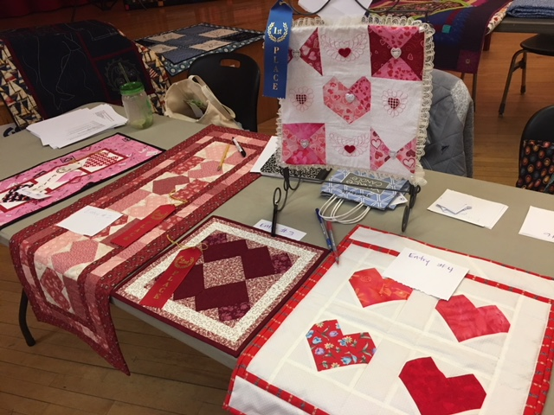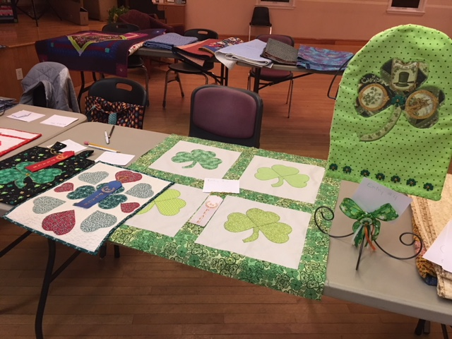

Winners for the Heart projects were:

1st: Jane Amato
2nd: tie between Connie Fitzgerald and ? (person who left their project behind!)
3rd: Kristin Callahan

Winners for the Shamrock projects were:

1st: Connie Fitzgerald
2nd: Ellen Moore
3rd: Kristin Callahan

2018 Quilt Show Committee: Martha Mazeika & Linda Reppucci, co-chairs
Our quilt show is fast approaching! More announcements, as well as registration and boutique forms, will be forthcoming in the next month or so.

In the meantime, get together with your table or with another group of friends to plan a donated raffle basket for the show. We always have about a dozen high-quality baskets. Some themes used for these baskets in the past have been: baby; wine; movie night; game night; notions and quilt kits; spa day; and Italian dinner. Use your imagination and come up with a great basket. Adrienne will have a signup sheet so you can “register” your idea. (While 12 wine baskets may sound wonderful to some people, we do strive for variety!) The “due date” for your basket will be announced soon.

You can also start (or continue) creating wonderful handmade items to sell in our boutique at the show. As in the past, when an item sells, you get 80% of the selling price and the guild gets 20%, a Win-Win for everyone!

Any questions, comments, or suggestions, don’t hesitate to contact us!
Secretary Report: Dottie Macomber
Printed reports containing the full minutes of all previous meetings for the current guild year, both general membership and executive board, will be available for your perusal at monthly guild meetings.

**********************************************************************************************************************
As the Secretary, I am also in charge of the Sunshine and Shadow “committee”. If you know of any member who has suffered a serious illness or accident or has had a death in the family, please let me know so I can send them a card on behalf of the guild: 781-932-3602 or mcandmac@comcast.net

Merle Gordon is recovering from hip replacement surgery and would love to hear from her friends in the guild. Her address is 15 Pleasant Ave., Saugus, MA 01906.

As to the “Sunshine” part of my job, if you have some good news that you would like to share with the guild, let me know that, too, so I can put it in the newsletter.

Member News: Dottie Macomber
She’s done it again! Janet Dalis and her “Splendid Sampler” quilt have won a First Place ribbon at MQX in the Emerging Entrants category. Congratulations again, Janet!!

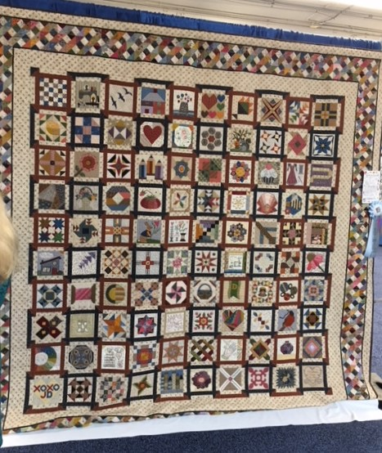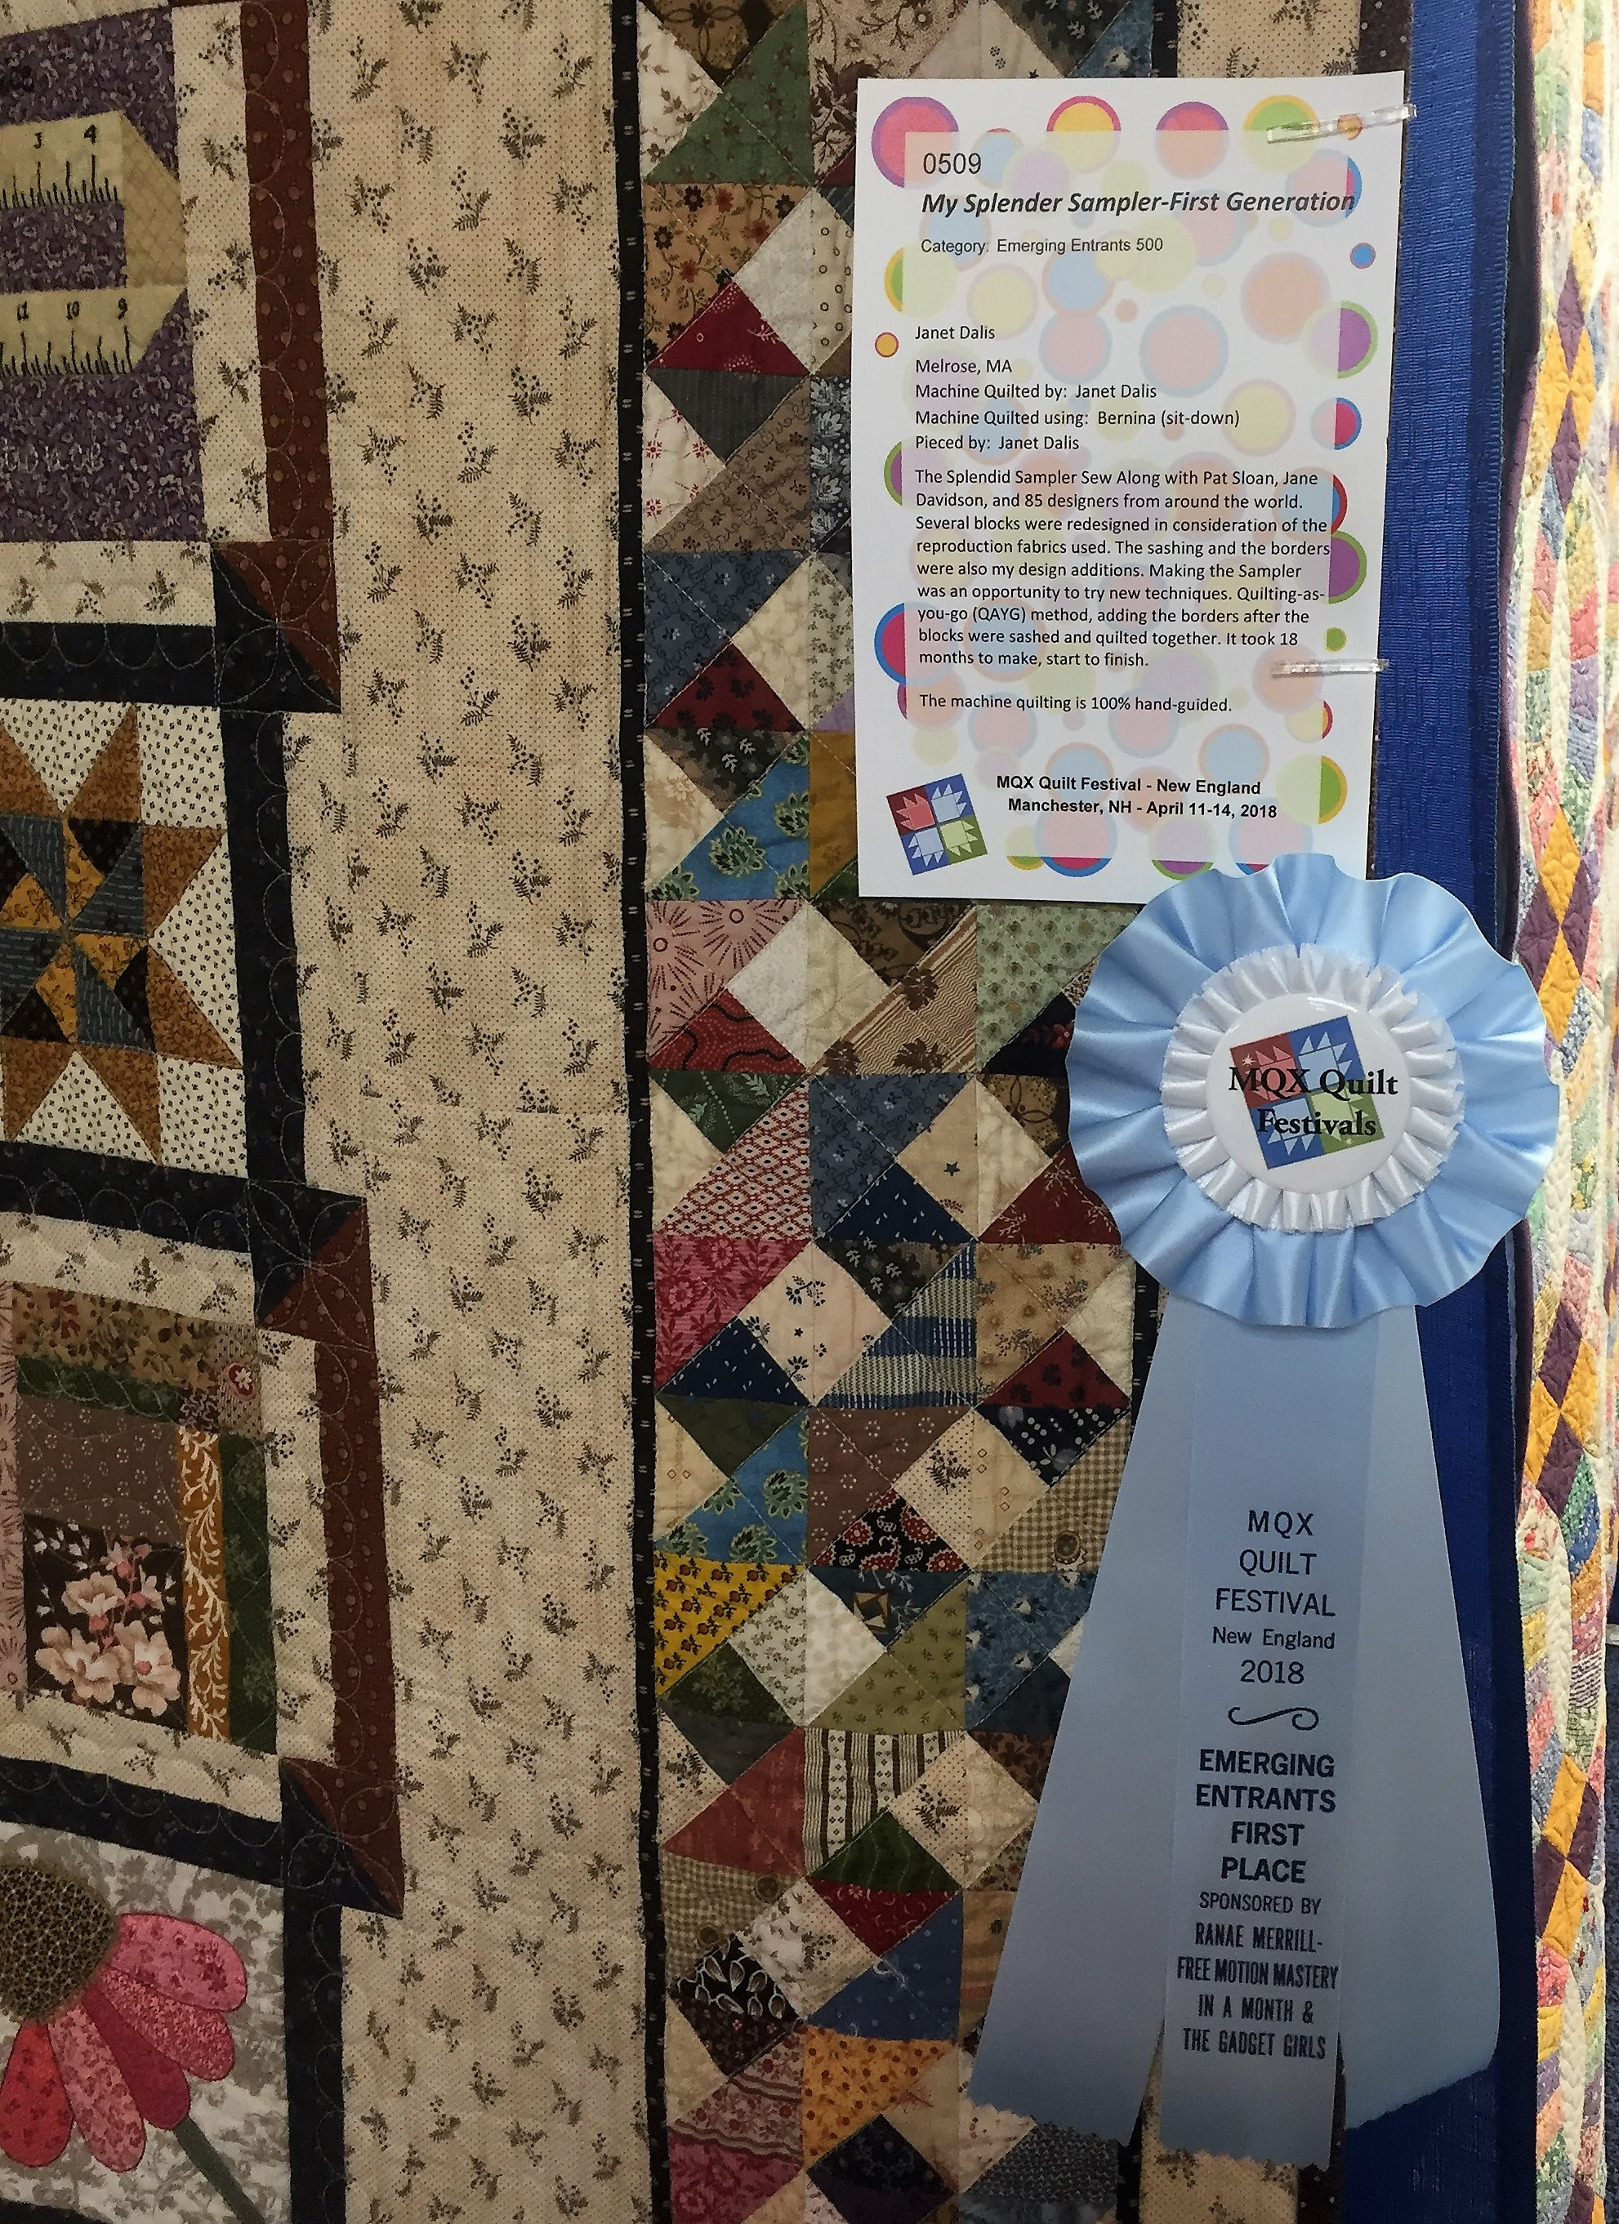

**********************************************************************************************************************
Congratulations to Kristin Callahan on becoming one of the newest Certified Instructors for Sue Pelland’s techniques!! (Maybe we can book Kristin to do a workshop for us! That “He Loves Me, He Loves Me Not” wallhanging she had at the Getaway was darn cute!)

Kristin also had a quilt in MQX called “Sue Rules”, which was made as part of the Sue Pelland 2018 Applique Design Challenge. The challenge was to create an original quilt design using appliqué elements cut using Sue Pelland’s Leaves Galore and/or Hearts and More tools. All designers started with one of four Kaffe Fassett Cameo panels and could use one or two green fabrics provided to unify the display of the finalist quilts.

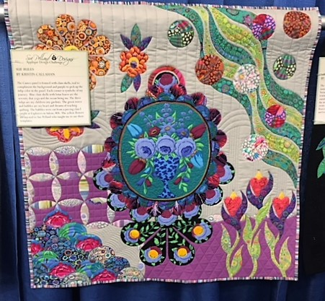 Kristin’s Sue Pelland challenge quilt

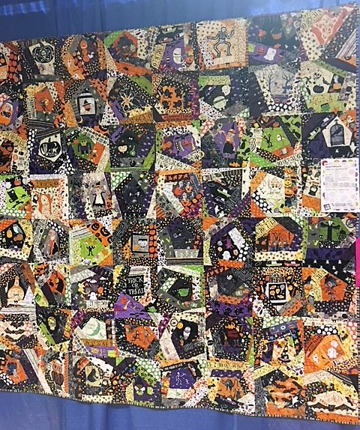
**********************************************************************************************************************

Heidi August also had a quilt entered at MQX:

**********************************************************************************************************************
I want to thank everyone at this year’s getaway for the wonderful but totally unnecessary gift certificates and quilt puzzle you gave me. It was my pleasure to organize our annual getaway weekend, and I’m glad everyone had a great time. I especially want to thank Louise Nazzaro for the hammer with the fabric-covered handle; it will be very useful for our ongoing home improvement projects, as well as for whacking things that are driving me crazy!!

**********************************************************************************************************************
If anyone submits quilts to shows or fairs, or if you have any other quilty accomplishments to report, please send the information (with photos if possible) to me, Dottie Macomber, at mcandmac@comcast.net or 9 Fletcher Rd, Woburn, MA 01801. Let us celebrate your quilty news with you!

Send me your quilting tips, too! I will share them in the newsletter if there is room or on the website.

News Around the Guilds and at the New England Quilt Museum
The New England Quilt Museum is open Tuesday through Saturday, 10-4 each day. Sunday hours from 12-4 begin in May. Remember, you can park on weekends for free in the lot behind the museum; access this lot from Middle Street across from the Life Alive! restaurant.
*********************************************************************************************************************
Be sure to check our website under the Bulletin Board tab; there are many quilt shows, both local and regional, this spring and summer. As I learn of them, I will post them on our website.

Respectfully submitted,
Dottie Macomber, Secretary

