Hammersmith Quilters Guild Newsletter

www.hqgsaugus.org June 2018

***For This Meeting***
June 6, 2018

Program: Ice Cream Social! Also, complete the annual Member Survey

Show 'n' Tell: YES!!!

Fat Quarter: Juvenile Prints

Refreshments: The Refreshment Committee, who is ordering the ice cream!!

Creative Quiltworks: Fabric Boxes

President’s Message: Martha Mazeika
Greetings Quilters!!!

Quilters Home magazine published “The Quilters Home Bill of Rights” in the July/August 2007 issue. I want to share with you these rights over the next few months as stated in the article:
- A quilter has the right to add a border fabric even if it’s not in the quilt pattern.
- A quilter has the right to join as many online quilting groups as humanly possible and spend time e-chatting instead of piecing.
- A quilter has the right to iron fabric-but not clothing.

We are making up the missed meetings on July 11th and August 8th. These meetings will be part of this current year. The 2018/2019 year will start in September 2018.

We now have an HQG email address: HQG.AskAnExpert@gmail.com
Please send us questions to help with programming this summer! (One of our summer meetings will feature other guild members answering your questions about tricky techniques, confusing construction, puzzling piecing- and any other quilty questions you may have! - Dottie)

Always here to listen, talk, discuss, and answer questions.
See you all on June 6th!!!!

Martha
(413)250-5449
marthamazeika@gmail.com

Reminder of schedule for monthly meetings:

6:30pm Hall opens
7:00pm-7:30pm Business meeting and Raffles
7:45pm-8:45pm Speaker/Other Program/Show ‘n’ Tell (when applicable)
8:45pm-9:00pm Good byes and Clean up
Please clean your tables, throw away trash, and pick up your snack containers at the end of the meeting.

Vice President’s Message: Gail Dwyer
Looking forward to a great bus trip Saturday, August 18, to the Mancuso World Quilt Show in Manchester, NH!!
We have 26 people signed up and we are hoping for 45!
Bring your checkbook in June. We will have more signups then and we will open the trip up to friends and other guilds at that time. Price is $28, which includes show admission + water + snacks + camaraderie + fabulous quilts + lots of great vendors!

Feel free to call me about the trip or send me an email
617-846-6551
Gaild516@aol.com

Treasurer’s Report: Carmen Arnone
As of May 15, the checkbook balance is $12,886.85.
After the last meeting, a member wondered why I only report the “working balance” at quilt guild meetings. My response was that I consciously choose not to use a lot of time & verbiage related to facts and figures that I suspect most members are not interested in or that they might not be able to retain in our meeting format. I choose to give my “time” to other officers’ reports.
Please be advised that I bring a binder to every meeting that has documentation for all monies coming in and going out of our account. Any member who wants a more detailed accounting of HQG finances can approach me and I will gladly share the facts & figures with you.
Just a reminder: if you make purchases on behalf of the guild, please submit your receipt(s) to me at guild meetings. If possible, I will write a check and reimburse you then and there. If not, I will mail the check to you ASAP. Remember: no receipt, no reimbursement!

Membership: Sally Nimblett
Welcome to our newest member Diane Bucknill from Melrose!! Glad to have you join us!

Sixty-five people signed in at the May meeting.

Dues for the 2018-2019 guild year will be due by the June meeting. The dues are $25 for ages 70 and older, and $30 for all others. I will collect them at the door as you sign in for the June meeting; you may pay by cash or by check made out to HQG. If you will not be at the June guild meeting, please mail your dues ASAP to Sally Nimblett, 22 Pleasant Park Rd, Winthrop, MA 02152. If you pay me now, I won’t have to hound you later!

Be sure to pick up a copy of this year’s Member Survey when you sign in. Complete it and return it to Dottie Macomber.

Just a reminder to everyone: be sure to sign in each month as you come in, or circle back to the front desk after you have dropped off your “stuff”. We like to keep attendance records because it helps us to know which programs/months are the most popular, and it give us an idea of how many handouts to prepare for meetings.
Refreshment Committee: Barbara Martinson & Kathy Connors
The following people will be bringing snacks for the June meeting: no one! We are having ice cream!!

Barbara will have a sheet available for folks to sign up to bring snacks in July and August for our “make-up” meetings. Perhaps the folks who were scheduled to bring snacks in February and March could sign up for one of our summer meetings.

New members: see Barbara or find her sign-up sheet at the Snack table to sign up to bring a snack for an upcoming meeting. We welcome any snacks: baked good and other sweets, crackers & cheese, veggies, and fruit!

Program Committee: Joyce Rodenhiser, Janice Moore & Dottie Macomber
We on the program committee try to take your feedback into consideration when planning activities. The annual Member Survey, completed by all of you each June, helps us know what you like, don’t like, and would like to see more of, so please take some time to fill it out and include helpful comments and suggestions. We know we can’t make everyone happy, but we try our best! Copies of the survey will be available at the June meeting; you can pick them up from Sally Nimblett when you sign in for the meeting.

If you are not going to be at the meeting, or if you would like to print it out on your own and complete it before the meeting, I have posted a link to this year’s survey on the website under the Newsletter tab. Print out and complete the survey and drop it off to Dottie at the June meeting. Or you may complete it and email it back to Dottie at mcandmac@comcast.net You may also mail it to her at 9 Fletcher Rd, Woburn, MA 01801. Thank you very much for completing the survey. We really do try to take your feedback into account when planning guild programs, activities and policy.

Charity Donations Committee: Gretchen Berkowitch, Sally Nimblett & Louise Nazzaro
We received a nice thank-you letter from the New England Quilt Museum for our annual donation.

Just a reminder: we are always collecting quilts (any size) and pillowcases to be donated to various charities, and this year we are also collecting doll quilts (sized approximately 16” x 20”) to be sold at our quilt show as a guild fund raiser. Members seem to be enjoying making these doll quilts, as we have received quite a few so far. These can be brought to any guild meeting. If you have any questions about these items, contact any member of this committee.

Creative Quiltworks Committee: Kristin Callahan, Ellen Moore & Lynda Garniss
The CQW project for June is Fabric Boxes. Let’s see how creative you are!

There will be ribbons for 1st, 2nd and 3rd place, and one winner will be chosen randomly from all entrants to receive a prize! Everyone is eligible to vote for their favorite, but only entrants will be eligible for ribbons or the raffle prize.

Please pick up directions for each project from Ellen, Lynda or Kristin. The directions for all the projects for this guild year are also available on the website under the Newsletter tab.

Winners for the Continuous Prairie projects in May were:

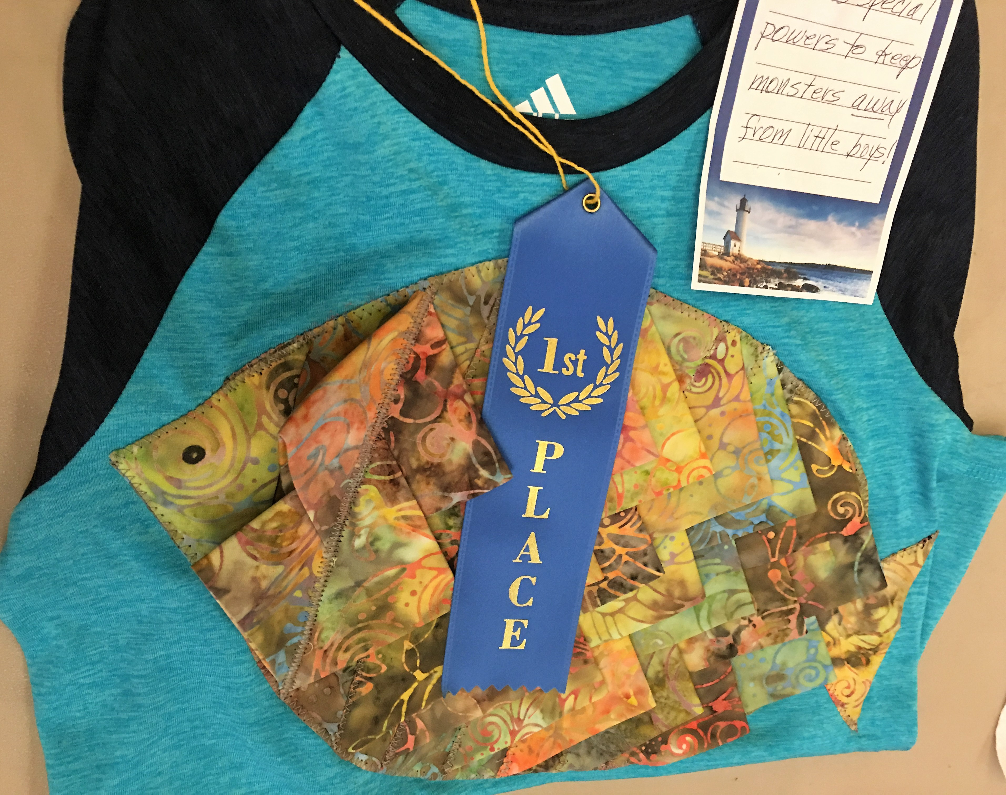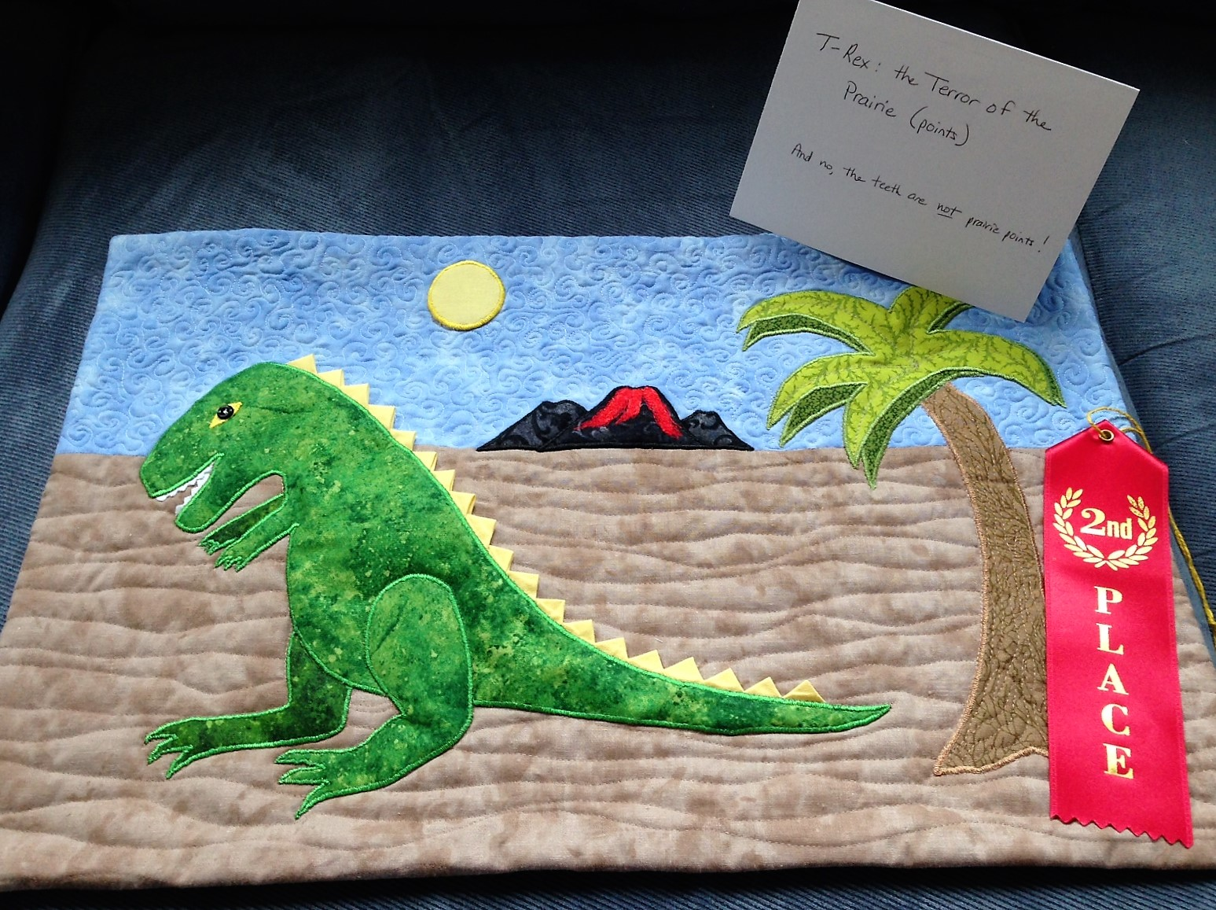

1st : Joyce Rodenhiser for the boy’s t-shirt with a fish
2nd: Dottie Macomber for her wallhanging, “T-Rex, the Terror of the Prairie (points)”

2018 Quilt Show Committee: Martha Mazeika & Linda Reppucci, co-chairs
Quilt Show Committee
The next Quilt Show Committee Meeting will be held on Thursday, May 24th, 5:30 pm-7:30 pm at the Saugus Public Library. If you are a committee chair and cannot make it, please send an update for your area to Linda or Martha.

Raffle Quilt
Raffle tickets and a picture of the quilt will be available for members at the June meeting. Please pick up your tickets then. Each member is expected to sell 2 books of tickets. If you don’t want to sell them, buy them yourself; maybe you’ll win the quilt! Of course, you can always take more than two books!

Registration forms will be available at the June meeting; pick them up from Holly Petersen. As has been past practice, no forms will be mailed; you must pick them up in person. We will also have them available at the July and August meetings, but keep in mind that your completed forms are DUE AT THE SEPTEMBER MEETING in order to give us enough time to prepare labels for the show. If you are not going to be at these meetings, please ask a friend to pick up a registration pack for you. Only the quilts listed on forms will be accepted- no substitutions- so think now about what quilts you want to enter. As in past years, each member can enter one quilt in each of the following categories: Large (bed-sized from twin to king); Small (wallhanging, baby quilt, lap quilt- smaller than a twin bed); Other (table runners, quilted clothing, quilted ornaments, etc.); Child age 12 or under sponsored by a guild member; and Challenge (this year the challenge is Polaroid block quilts). If you want to enter more than one item in a category, trade forms with someone who does not need that entry form. There is limited space in the senior center, so we can’t have everyone displaying, for example, 5 large king-size quilts! We want to show off everyone’s work to the best advantage, which is why we have limits on the number of entries per person.

Because the revenues generated by the quilt show benefit everyone in the guild, we ask that you all volunteer for at least 2 hours either during the show, during set-up on Friday October 19, or during take-down on Sunday October 21. Holly Petersen is the volunteer coordinator. Please sign up for your shift with Holly; she can let you know where and when we need help. We have several sit-down jobs (selling raffle quilt and raffle basket tickets; working admissions; and working in the boutique) as well as stand-up jobs (hosts/hostesses directing visitors to various areas of the senior center and answering guests’ questions; white-glove duty, roaming the show and showing visitors the backs of quilts; and announcing door prize numbers in the rooms that are beyond the reach of Dottie’s voice on the mike!). If you need a sit-down job, please see Holly early before the time slots for those jobs are gone.
In addition to doing your part for the guild, volunteering gets you free admission to our show! (Otherwise, admission is $6.00.)

Don’t forget to start working on a raffle basket for the show. Get together with several friends and design and fill a themed basket for us to raffle. See Adrienne Nolan to register your idea (baby, wine, spa, game night, Italian dinner, barbeque, etc.). We will need your basket filled with items in the fall.

You can also start (or continue) creating wonderful handmade items to sell in our boutique at the show. As in the past, when an item sells, you get 80% of the selling price and the guild gets 20%, a Win-Win for everyone!

Any questions, comments, or suggestions don’t hesitate to contact us!
Martha & Linda

Secretary Report: Dottie Macomber
Printed reports containing the full minutes of all previous meetings for the current guild year, both general membership and executive board, will be available for your perusal at monthly guild meetings.

**********************************************************************************************************************
As the Secretary, I am also in charge of the Sunshine and Shadow “committee”. If you know of any member who has suffered a serious illness or accident or has had a death in the family, please let me know so I can send them a card on behalf of the guild: 781-932-3602 or mcandmac@comcast.net

As to the “Sunshine” part of my job, if you have some good news that you would like to share with the guild, let me know that, too, so I can put it in the newsletter.

Member News: Dottie Macomber
Congratulations to Gretchen Berkowitch, who has had her quilt, “Eureka”, accepted into the Vermont Quilt Festival!

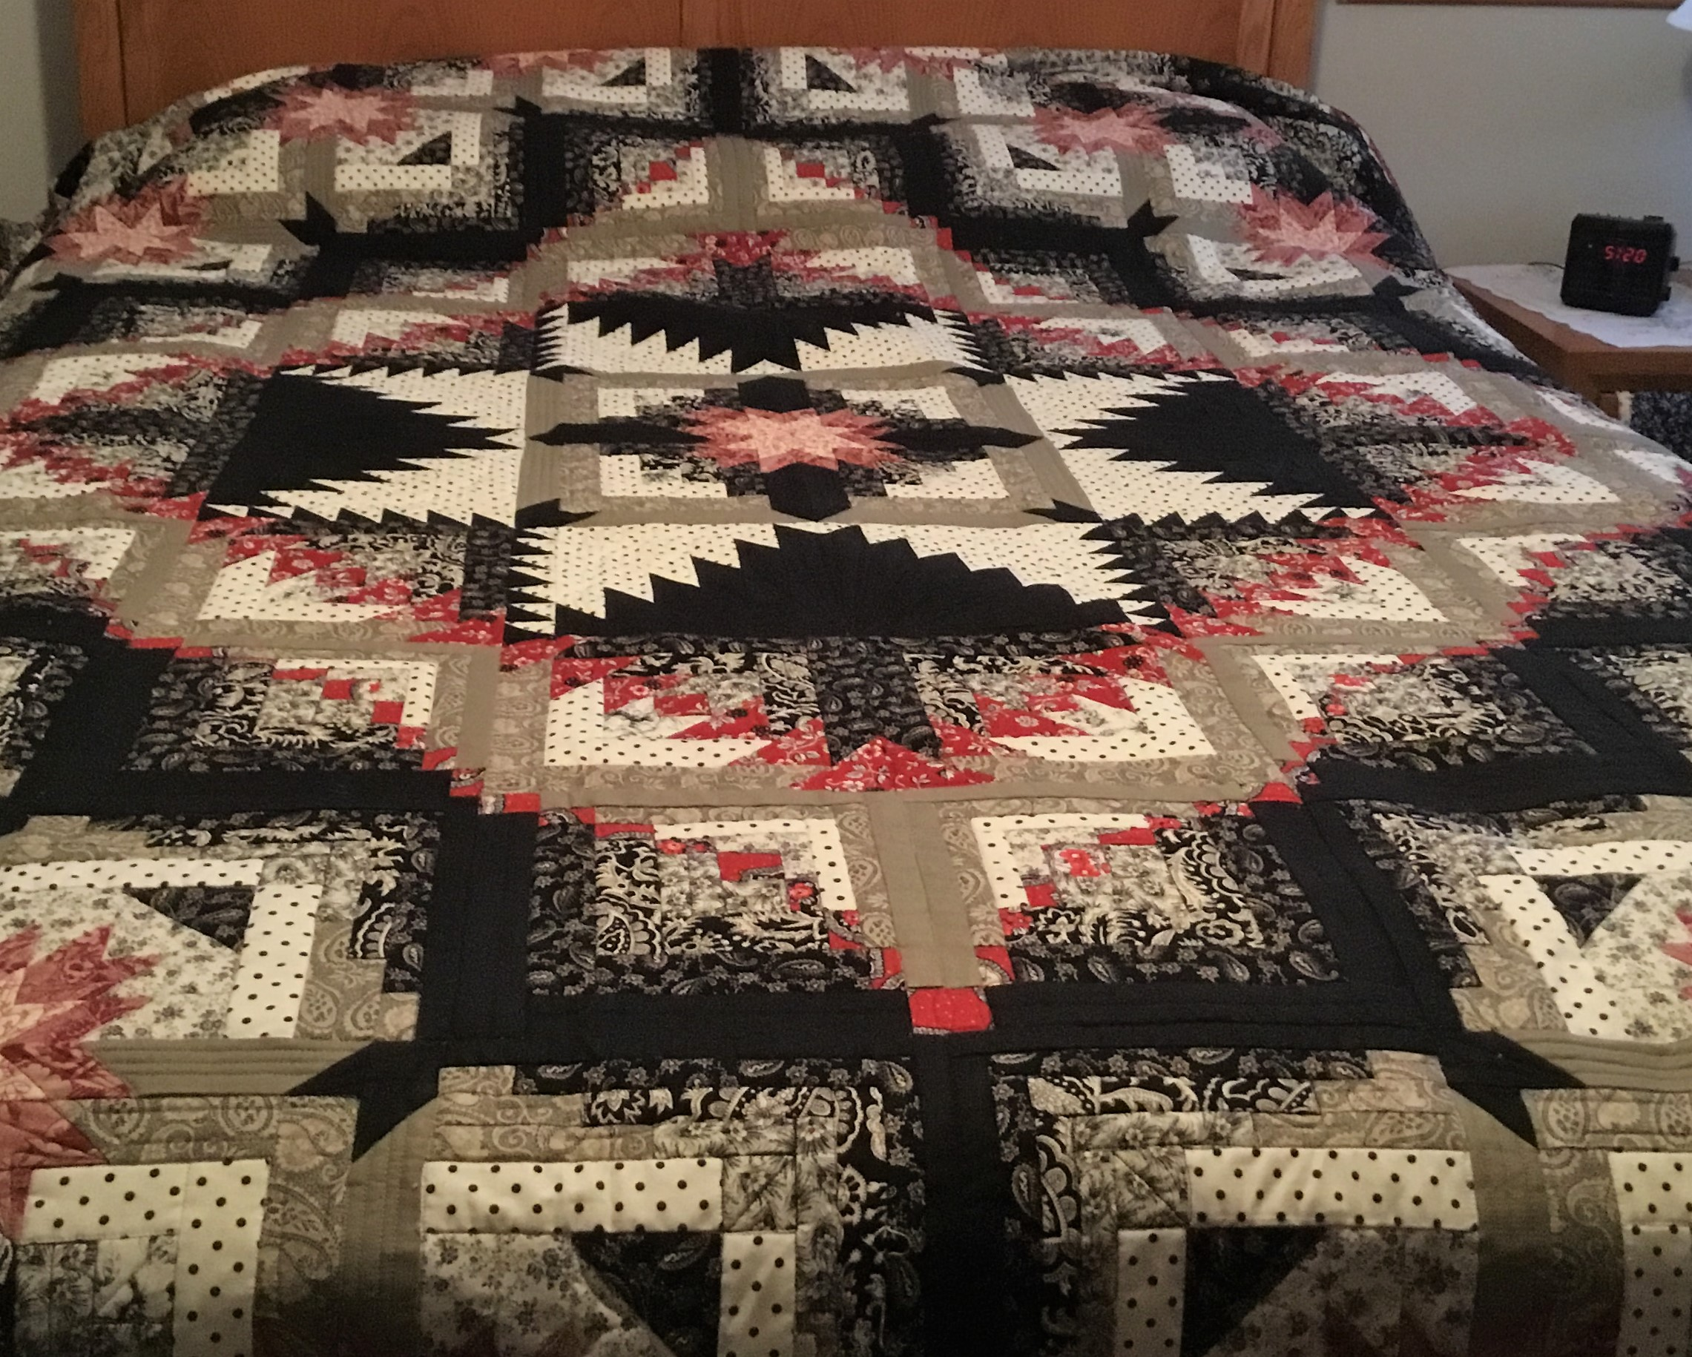

**********************************************************************************************************************
If anyone submits quilts to shows or fairs, or if you have any other quilty accomplishments to report, please send the information (with photos if possible) to me, Dottie Macomber, at mcandmac@comcast.net or 9 Fletcher Rd, Woburn, MA 01801. Let us celebrate your quilty news with you!

Send me your quilting tips, too! I will share them in the newsletter if there is room or on the website.

News Around the Guilds and at the New England Quilt Museum
The New England Quilt Museum is now open for its summer hours, Tuesday through Sunday, from 10:00 to 4:00 each day. Remember, you can park on weekends for free in the lot behind the museum; access this lot from Middle Street across from the Life Alive! restaurant.

*********************************************************************************************************************
And speaking of the museum: I have a request. While I appreciate the book and magazine donation I got last month for the museum’s library, please do not give me magazines with pages torn out. If we notice this, we cannot put them in the library’s permanent collection (if they are issues we don’t have) or sell those copies (if they are extras) and just have to recycle them. If we don’t notice the missing pages and someone buys or wants to buy that issue, it is a big disappointment to that person when they discover that the one article they really wanted is missing or incomplete. So please: don’t bring those magazines to guild meetings; just recycle them yourselves.

The museum library accepts donations of magazines that are no older than 10 years as well as quilting books (not general sewing or crafting books) that are no older than 20 years. Thank you for thinking of the museum when you are cleaning out your book and magazine stash and for adhering to these donation guidelines.

*********************************************************************************************************************
Be sure to check our website under the Bulletin Board tab; there are many quilt shows, both local and regional, this spring and summer. As I learn of them, I will post them on our website.

Respectfully submitted,
Dottie Macomber, Secretary

