Hammersmith Quilters Guild Newsletter

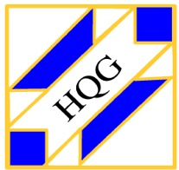

www.hqgsaugus.org July 2018

***For This Meeting***
July 11, 2018

Program: Member Demos (see below)

Show 'n' Tell: No

Fat Quarter: Batiks

Refreshments: Gail Dwyer, Denise Moran, Joyce Rodenhiser, Janice Moore, Dottie Macomber, and Donna Cormier (water)

Creative Quiltworks: Origami Fabric Fun

President’s Message: Martha Mazeika
[Editor’s note: At the June guild meeting, Martha mentioned that we are temporarily suspending the use of the “free stuff” table at meetings where folks can bring unwanted fabric, tools, etc. Too many items have been left on the table at the end of the night, making it necessary for someone to dispose of those things before the center is locked up for the night. Most times this has been Margie Berkowitch, and this is not fair to Margie or anyone else who has to clean up the unwanted stuff. If members are interested in restarting the “free stuff” table, we will revisit this issue in the fall.]

Greetings Quilters!!!

Quilters Home magazine published “The Quilters Home Bill of Rights” in the July/August 2007 issue. I want to share with you these rights over the next few months as stated in the article:
- A quilter has the right to take side trips on family vacations that will take them to a new quilt shop to explore and support.
- A quilter has the right to burn gasoline for a complete shop hop – if only for one fat quarter.

It was a great year and I have been honored to serve as the president for HQG. I am glad we are making up the missed meetings on July 11th and August 8th. It will be great to see those who can attend throughout the summer! I will need a couple of volunteers to do the 3 for $1 and Fat Quarters raffles. If there are comments or questions you have for me as we plan for the next year with this executive board, please let me know.

We now have an HQG email address: HQG.AskAnExpert@gmail.com
- A request came in for someone who has experience with making a scalloped border. Let me know if you can help with this!!!!
- Don’t forget to send your questions so we can help each other!

I wish all of you a safe and happy summer.

Always here to listen, talk, discuss, and answer questions.
See you all on July 11th!!!!

Martha
(413)250-5449
marthamazeika@gmail.com

Reminder of schedule for monthly meetings:

6:30pm Hall opens
7:00pm-7:30pm Business meeting and Raffles
7:45pm-8:45pm Speaker/Other Program/Show ‘n’ Tell (when applicable)
8:45pm-9:00pm Good byes and Clean up
Please clean your tables, throw away trash, and pick up your snack containers at the end of the meeting.

Vice President’s Message: Gail Dwyer
Looking forward to a great bus trip Saturday, August 18, to the Mancuso World Quilt Show in Manchester, NH!! The bus will leave from the Saugus Senior Center at 8:30 a.m. and return at approximately 6:00 p.m.

If you are interested, please contact Gail ASAP and get your payment to her, as there has been interest from friends and other guilds. Secure your spot now! Price is $28, which includes show admission + water + snacks + camaraderie + fabulous quilts + lots of great vendors!

617-846-6551
Gaild516@aol.com

Treasurer’s Report: Carmen Arnone
After depositing membership dues received from Sally and accounting for checks written in June, our working balance is $13,363.77.
Just a reminder: if you make purchases on behalf of the guild, please submit your receipt(s) to me at guild meetings. If possible, I will write a check and reimburse you then and there. If not, I will mail the check to you ASAP. Remember: no receipt, no reimbursement!

Membership: Sally Nimblett
Fifty-six people signed in at the June meeting. It seemed as if there were more than that; perhaps some of you were eager to get to the ice cream!

Dues for the 2018-2019 guild year were due by the June meeting. The dues are $25 for ages 70 and older, and $30 for all others. Please mail your dues ASAP to Sally Nimblett, 22 Pleasant Park Rd, Winthrop, MA 02152. If you pay me now, I won’t have to hound you later! Members who pay now will receive preprinted guild membership cards at the September meeting; these are good for discounts at shops who give guild discounts as well as at Jo-Ann Fabrics when you apply for a Jo-Ann’s discount card.

Annual Member Surveys were passed out at the June meeting. For anyone who missed them, or who was unable to download them from the website, they will also be available at the July and August meetings. We would appreciate your feedback so we can plan meetings, programs and activities that you, our members, want.

Just a reminder to everyone: be sure to sign in each month as you come in, or circle back to the front desk after you have dropped off your “stuff”. We like to keep attendance records because it helps us to know which programs/months are the most popular, and it give us an idea of how many handouts to prepare for meetings.

Refreshment Committee: Barbara Martinson & Kathy Connors
The following people will be bringing snacks for the July meeting: Gail Dwyer, Denise Moran, Joyce Rodenhiser, Janice Moore, Dottie Macomber, and Donna Cormier (water).

Everyone: please see Barbara or find her sign-up sheet at the Snack table to sign up to bring a snack for an upcoming meeting. We welcome any snacks: baked good and other sweets, crackers & cheese, veggies, and fruit!

Program Committee: Joyce Rodenhiser, Janice Moore & Dottie Macomber
Our July 11th meeting will feature the ever-popular Member Demos! Following are the members and their demo topics:

- Janice Moore will demonstrate applique. She is a prize-winning appliquer!!
- Rosie Graham will show us how to use the Quilting Calculators App by Robert Kaufman and the Free Online Quilting Calculators on the Paradise Quilting Website. The quilting calculator app is available for free download for android, Amazon, and Apple products through their app stores. A URL will be provided for the Online Quilting Calculators. If you bring your smart devices, she will have her IT helpers (grandson and his friend) help you download the app. These apps calculate fabric requirements for borders, backing, batting, and bindings. In addition, they can tell you if you have enough fabric for the number of square or rectangular pieces you need for a quilt.
- And Joyce hopes to send you home with either a quilted greeting card or a postcard. For Joyce’s demo, please bring a 4"x 6" block (could be red work, 9 patch, modern art, or just a 4"x 6" piece of fabric that you like), a basic sewing kit of thread, needle, scissors, thimble. Joyce will supply the card or Peltex, index cards, and tape.

Our August 8th meeting will feature “Ask An Expert”! Yes, you are the experts!

- You CAN finish that quilt!! Got a quilt with which you are so frustrated that you feel like taking it to the dumpster? STOP! Bring it to Guild in August and get suggestions from your friends. If no one at your table has an idea, go to the next table - until your problem has been solved.
- Do you have orphan blocks you don't know what to do with? Ask others, write down all the suggestions - this is Brainstorming where no ideas are put down!! With all the advice you will get, you are bound to find ways to use your orphan blocks.
- Making a quilted jacket, a pocketbook, or a table runner that is not quite right? Bring it to the August meeting and ask the experts!

If you have a question about some tricky technique, or if you have a problem with some aspect of quilting, you may also send your question now to HQG.AskAnExpert@gmail.com and we will be sure to find an expert from within our midst who can answer your question or show you how to do the technique. We already have one question about making a scalloped edge on a quilt. Submit your questions now so we can find the appropriate expert to help. Remember, there are no stupid questions! If you have that question, chances are others want the answer, too, so ask away! Here’s a chance to create a meeting that is customized to the needs of you, our members!!

Charity Donations Committee: Gretchen Berkowitch, Sally Nimblett & Louise Nazzaro
Just a reminder: we are always collecting quilts (any size) and pillowcases to be donated to various charities, and this year we are also collecting doll quilts (sized approximately 16” x 20”) to be sold at our quilt show as a guild fund raiser. Members seem to be enjoying making these doll quilts, as we have received quite a few so far. These can be brought to any guild meeting. If you have any questions about these items, contact any member of this committee.

Creative Quiltworks Committee: Kristin Callahan, Ellen Moore & Lynda Garniss
The CQW project for June is Origami Fabric Fun. You have a choice of several projects- or perhaps you know some other fabric origami. Let’s see how creative you are!

There will be ribbons for 1st, 2nd and 3rd place, and one winner will be chosen randomly from all entrants to receive a prize! Everyone is eligible to vote for their favorite, but only entrants will be eligible for ribbons or the raffle prize.

Please pick up directions for each project from Ellen, Lynda or Kristin. The directions for all the projects for this guild year are also available on the website under the Newsletter tab.

Winners for the Fabric Boxes projects in June were:

1st : Dottie Macomber
2nd: Ellen Moore
3rd: Kristin Callahan
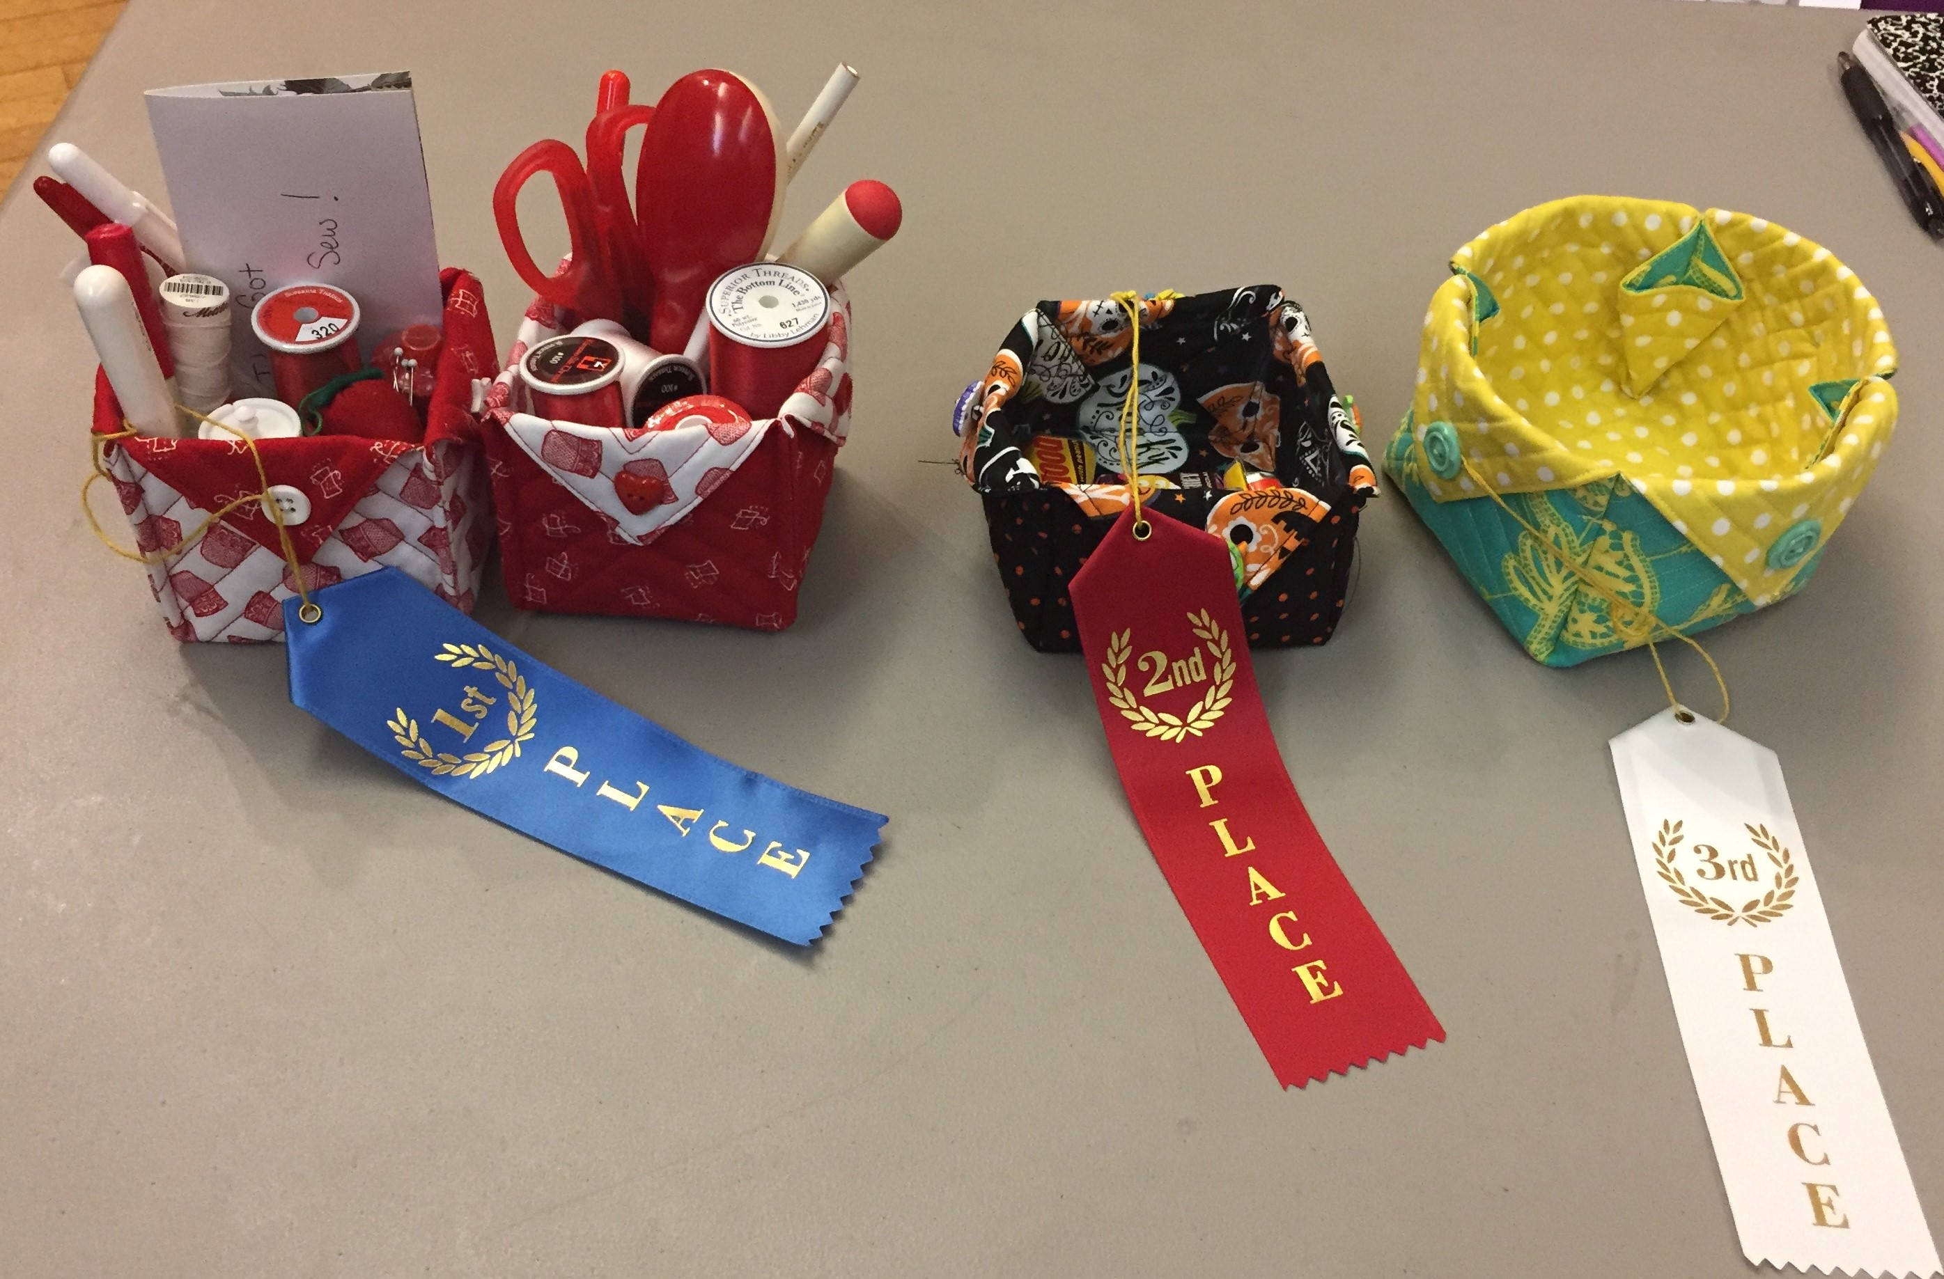

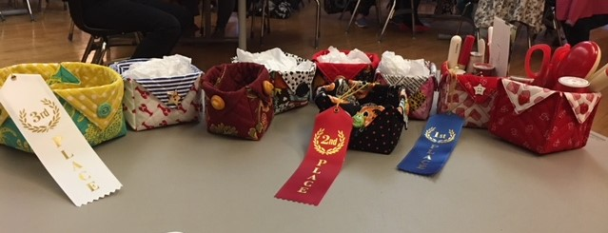

Here are all of the great entries for the June CQW challenge.

2018 Quilt Show Committee: Martha Mazeika & Linda Reppucci, co-chairs
Quilt Show Committee
The next Quilt Show Committee Meeting will be held on Thursday, June 28th, 5:30 pm-7:30 pm at the Saugus Public Library. If you are a committee chair and cannot make it, please send an update for your area to Linda or Martha.

Raffle Quilt
Raffle tickets and photos of the quilt were available at the June meeting and will be available at meetings from now through the show. Please pick up your tickets from Dottie. Each member is expected to sell 2 books of tickets. (Tickets are $1 each or a book of 6 tickets for $5.) If you don’t want to sell them, buy them yourself; maybe you’ll win the quilt! Of course, you can always take more than two books! There is a prize of a kit for a great fall wallhanging from ShabbyFabrics.com for the person selling the most tickets! Turn in your ticket stubs and money (cash or check) to Dottie.

Registration forms are now available; pick them up from Holly Petersen. As has been past practice, no forms will be mailed; you must pick them up in person. We will have them available at the July and August meetings, but keep in mind that your completed forms are DUE AT THE SEPTEMBER MEETING in order to give us enough time to prepare labels for the show. If you are not going to be at these meetings, please ask a friend to pick up a registration pack for you. Only the quilts listed on forms will be accepted- no substitutions- so think now about what quilts you want to enter. As in past years, each member can enter one quilt in each of the following categories: Large (bed-sized from twin to king); Small (wallhanging, baby quilt, lap quilt- smaller than a twin bed); Other (table runners, quilted clothing, quilted ornaments, etc.); Child age 12 or under sponsored by a guild member; and Creative Quiltworks Challenge (this year the challenge is Polaroid block quilts). If you want to enter more than one item in a category, trade forms with someone who does not need that entry form. There is limited space in the senior center, so we can’t have everyone displaying, for example, 5 large king-size quilts! We want to show off everyone’s work to the best advantage, which is why we have limits on the number of entries per person.

Volunteering
Because the revenues generated by the quilt show benefit everyone in the guild, we ask that you all volunteer for at least 2 hours either during the show, during set-up on Friday October 19, or during take-down after the show on Sunday October 21. Holly Petersen is the volunteer coordinator. Please sign up for your shift with Holly; she can let you know where and when we need help. We have several sit-down jobs (selling raffle quilt and raffle basket tickets; working admissions; and working in the boutique) as well as stand-up jobs (hosts/hostesses directing visitors to various areas of the senior center and answering guests’ questions; white-glove duty, roaming the show and showing visitors the backs of quilts; and announcing door prize numbers in the rooms that are beyond the reach of Dottie’s voice on the mic!). If you need a sit-down job, please see Holly early before the time slots for those jobs are gone.
In addition to doing your part for the guild, volunteering gets you free admission to our show! (Otherwise, admission is $6.00.)

If you are unable to volunteer during the show, we have two other opportunities for you to fulfill your volunteer duty. We need volunteers to sell tickets for our raffle quilt on Saturday, July 14th, at the New England Quilt Museum in Lowell. The museum is open from 10-4, and we are asking for people who can do a 2-hour shift. Dottie will be there at 9:30 to set up and to do the first two hours. Ideally, we would like two people on each two-hour shift, so we need five more people to volunteer here. A bonus: you can see the exhibits at the museum before or after your shift!

The second opportunity is selling tickets for our raffle quilt during the Founders Day event in Saugus on Saturday, September 8th; setup is 8:30-9:30, cleanup around 2:00. Margie Berkowitch will be doing a shift, but she needs several more people to help out.

Raffle Baskets
Don’t forget to start working on a raffle basket for the show. Get together with several friends and design and fill a themed basket for us to raffle. See Adrienne Nolan to register your idea (baby, wine, spa, game night, Italian dinner, barbeque, lottery tickets, etc.). We will need your basket filled with items in the fall.

Adrienne also needs LOTS of good quality fat quarters to make up our huge and hugely-popular raffle basket FULL of fat quarters! Any colors, solids or prints, any types of 100% cotton quilt-shop quality FQs are welcome. (Just check to make sure you aren’t donating one that you cut that little piece out of when you needed the perfect little piece for an applique project!)

Boutique

Bev McGrath would like you to know that forms for the boutique, including guidelines/instructions and an inventory sheet, will be available at the July meeting. (They will also be available soon on the guild website.) There is no deadline for passing in your inventory sheets; just bring them with your boutique items on Friday, October 19, on quilt show set-up day. Just let Bev know now that you will be selling boutique items so she can assign a number to you for your tags. As in the past, when an item sells, you get 80% of the selling price and the guild gets 20%, a Win-Win for everyone! You have all summer, September, and much of October to create great handmade items for the boutique. Participation is encouraged to make our boutique a success!

Any questions, comments, or suggestions don’t hesitate to contact us!
Martha & Linda

Secretary Report: Dottie Macomber
Printed reports containing the full minutes of all previous meetings for the current guild year, both general membership and executive board, will be available for your perusal at monthly guild meetings.

**********************************************************************************************************************
As the Secretary, I am in charge of the Sunshine and Shadow “committee”. If you know of any member who has suffered a serious illness or accident or has had a death in the family, please let me know so I can send them a card on behalf of the guild: 781-932-3602 or mcandmac@comcast.net

Ruth Ruggeri has been hospitalized after suffering a massive stroke. We are keeping her in our thoughts as she recovers. Cards may be sent to her home address: 2 Lenox Ave, Saugus, MA 01906.

Pam Strout is recovering from shoulder surgery and is at home and doing well.

Mary Ann Andree is recovering from a fracture in her foot and is sorry that she missed the ice cream last month!

Former member Ginny McDormand of Lynn has passed away. You may send cards to her family in care of Cuffe-McGinn Funeral Home, 157 Maple St., Lynn, MA 01904.

Member News: Dottie Macomber
Okay, this is getting repetitive: Linda Anthony has yet another pattern published in the online magazine, The Quilt Pattern Magazine! This one is in the July issue. Congratulations!! Actually, Linda’s had one or two other patterns published recently that I think I forgot to mention. It’s becoming old hat- I swear, Linda, you are almost single-handedly keeping them in business!!

If anyone submits quilts to shows or fairs, or if you have any other quilty accomplishments to report, please send the information (with photos if possible) to me, Dottie Macomber, at mcandmac@comcast.net or 9 Fletcher Rd, Woburn, MA 01801. Let us celebrate your quilty news with you!

Send me your quilting tips, too! I will share them in the newsletter, if there is room, or on the website.

News Around the Guilds and at the New England Quilt Museum
The New England Quilt Museum is taking part in Free Fun Fridays!
Friday, July 6 · 10 am - 4 pm, Free Fun Friday at the NEQM!

​Thanks to a grant from the Highland Street Foundation, the Museum will be free of charge all day.

The museum is now open for its summer hours, Tuesday through Sunday, from 10:00 to 4:00 each day. Remember, you can park on weekends for free in the lot behind the museum; access this lot from Middle Street across from the Life Alive! restaurant.

*********************************************************************************************************************
The museum library accepts donations of quilting magazines that are no older than 10 years as well as quilting books (not general sewing or crafting books) that are no older than 20 years. Thank you for thinking of the museum when you are cleaning out your book and magazine stash and for adhering to these donation guidelines. Please be sure that any magazines you donate do not have pages torn out.

*********************************************************************************************************************
Be sure to check our website under the Bulletin Board tab; there are many quilt shows, both local and regional, this spring and summer. As I learn of them, I will post them on our website.

Just for Fun
Joyce Rodenhiser recently told me about a website, www.ranaemerrillquilts.com RaNae Merrill teaches classes in making Haikuilts. What is a haikuilt? It is a small art quilt that accompanies and expresses a haiku, the ancient Japanese form of poetry best known for its 3-line, 17-syllable structure: 5 syllables in the first line, 7 in the second, and 5 in the third. Haiku + Quilt = Haikuilt

Here is one of RaNae’s haikus:

Too many pieces!!
Too much hair being pulled out!!
WOW! What a great quilt!!

See our website for other examples. They are under the Tips and Quotes tab.

I tried writing one of my own. Here’s my quilt haiku:

Beautiful fabric
Measure before you cut, then
Measure one more time!

Anyone else want to try one? This might make an interesting Creative Quiltworks challenge: write a quilting haiku and make a small art quilt to go with it. What do you think, Kristin? Maybe the challenge category for our 2020 quilt show? Something to think about…

Respectfully submitted,
Dottie Macomber, Secretary

