Hammersmith Quilters Guild Newsletter

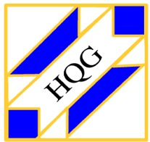

www.hqgsaugus.org February 2018

***For This Meeting***
February 7, 2018

Program: Member Trunk Show

Show 'n' Tell: YES

Fat Quarter: Florals

Refreshments: Lauren Loughlin, Jean Balliro, John Balliro, Pam Strout, Ruth Ruggeri, Marcia Karalis, Pat Burwell, Carol d'Entremont, Sally Clapp, Bernadette Reilly-Smorawski, and Donna Cormier (water)

Creative Quiltworks: Paper-pieced Heart project

Raffle Quilt Blocks: If you took a color swatch to make a block for our raffle quilt and have not already handed in your block, please be sure to bring it to the February meeting.

President’s Message: Martha Mazeika
Welcome!

Moving into February, we are going to feature a few of our own guild members at the next meeting to do a trunk show. I am looking forward to having our own members show us their skills and thoughts about their quilting adventures as we all have a story to tell. Do you keep a quilt journal to help document your own quilt story? I have one but have not entered many pictures in it in the last few years. I don’t know if that is because it takes an effort to print the pictures. It seems like my Facebook page has become a place where I will take a picture and post whichever small project I have completed. This is quicker, and many people get to see it. I wonder if that is true for you: has your social media page become a journal for your quilting journey? If you have a story to tell, please let the programming committee know so we can feature you at a meeting!

Martha
(413)250-5449
marthamazeika@gmail.com

Reminder of schedule for monthly meetings:
6:30pm Hall opens
7:00pm-7:30pm Business meeting and Raffles
7:45pm-8:45pm Speaker/Other Program/Show ‘n’ Tell (when applicable)
8:45pm-9:00pm Good byes and Clean up
Please clean your tables, throw away trash, and pick up your dessert trays at the end of the meeting.

Treasurer’s Report: Carmen Arnone
Despite lower-than-usual attendance, our annual auction at the January meeting did quite well. Twenty-five people bid on 43 items, and $371 was raised for the guild!

As of January 3, 2018, the balance in the treasury was $16,315.75. This includes over $8,000 in getaway payments, which will be paid out to the Saco Ramada Inn and Conference Center.

Just a reminder: if you make purchases on behalf of the guild, please submit your receipt(s) to me at guild meetings. If possible, I will write a check and reimburse you then and there. If not, I will mail the check to you ASAP. Remember: no receipt, no reimbursement!

Membership: Sally Nimblett
Fifty people signed in at the January meeting. The cold as well as the ice and snow underfoot, and the traffic caused by folks panicking before the nor’easter, surely kept attendance down. However, those who attended were treated to a fun time at the annual auction.

Please be sure to sign in each month as you come in, or circle back to the front desk after you have dropped off your “stuff”. We like to keep attendance records because it helps us to know which programs/months are the most popular, and it give us an idea of how many handouts to prepare for meetings.

Refreshment Committee: Barbara Martinson & Kathy Connors
The following people will be bringing snacks for the February meeting: Lauren Loughlin, Jean Balliro, John Balliro, Pam Strout, Ruth Ruggeri, Marcia Karalis, Pat Burwell, Carol d'Entremont, Sally Clapp, Bernadette Reilly-Smorawski, and Donna Cormier (water)

Program Committee: Julie Legere & Dottie Macomber
Our Annual Auction in January was a success, despite the lower than average attendance. There were bargains galore, as some people stuffed their clear ziplock bags FULL of fabric and other goodies. There were some bags that sold for only $3, and there was some spirited bidding for a few bags that held treasures coveted by many people. The biggest winner was Louise Nazzaro, the lucky high bidder of the venerated Junque, our historic and traditional auction item that is a holdover from the days when our guild met in the East Saugus Methodist Church basement and our auctions were more like yard sales and could include ANYthing, not just sewing and quilting items. Despite competition from Dottie, Louise prevailed and, for the first time ever she was able to become the caretaker of the Junque. Take good care of the Junque, Louise, display it in a place of prominence in your home, and be sure to bring it back next year so someone else has the chance to take home this piece of Hammersmith history!

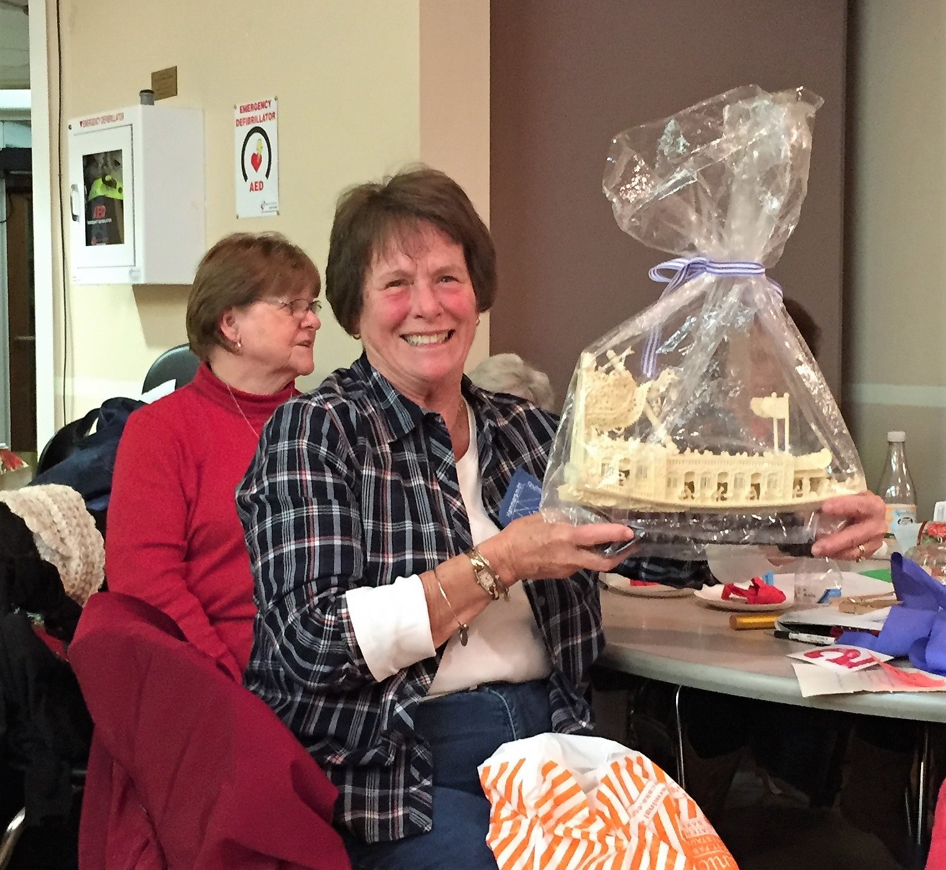

********************************************************************************************************************

March getaway weekend: We have a total of 48 people coming on the getaway, so we are filled to capacity! This number includes 41 guild members and 7 nonmember friends. It is shaping up to be a great time!

Just a reminder about mini refrigerators in our guest rooms. Some rooms come with them and some rooms do not. The others they have in the hotel are available on a first-come, first served basis. If you absolutely must have a fridge in your room, such as for medication that needs to be refrigerated, you must let Dottie know by the February meeting so she can inform the hotel. (Wine is not medication!! LOL There will be a large fridge in the conference center sewing room that we can use for that.) Otherwise, if your room does not come with a fridge but you would like one if it’s available, please let Dottie know so she can pass that information on to the hotel this month when she gives them the rooming list. If you want a fridge and your room does not come with one, there will be a separate charge of $10 per night that you will settle with the hotel yourself when you check out.

More information about the getaway schedule and quilt shops in the area will be forthcoming later this month. Dottie will also send a list of some of the restaurants in the area for those who are going up on Thursday night and for those who want to go out for lunch on Friday and Saturday, as lunches and Thursday night dinner are not included in our package. Stay tuned!

*********************************************************************************************************************

Another “stay tuned” item: if all can be arranged, we may be having a workshop with our March speaker, Allison Wilbur, on Quilting as a Design Element. Stay tuned for more information!

Charity Donations Committee: Gretchen Berkowitch, Sally Nimblett & Louise Nazzaro
Just a reminder: we are still collecting quilts (any size) and pillowcases to be donated to various charities, and doll quilts (sized approximately 16” x 20”) to be sold at our quilt show as a guild fund raiser. These can be brought to any guild meeting. If you have any questions about these items, contact any member of this committee.

Creative Quiltworks Committee: Kristin Callahan, Ellen Moore & Lynda Garniss
The project for February is a 4 ½” (finished) paper-pieced heart, which you can incorporate into any quilty creation. You may use one heart or more than one. Bring your creation to the February meeting for voting by the membership. Directions are on the guild website; if you do not have access to the internet and would like a copy of the directions, please let Dottie know right away so she can mail them to you. (Dottie’s number is 781-932-3602.)

There will be ribbons for 1st, 2nd and 3rd place, and one winner will be chosen randomly from all entrants to receive a prize! Everyone is eligible to vote for their favorite, but only entrants will be eligible for ribbons or the raffle prize.

Please pick up directions for the next project from Ellen, Lynda or Kristin. The directions for the current project, as well as the previous projects for this guild year, are available on the website under the Newsletter tab.

Winners in January for their North Star potholders were Kristin Callahan (1st), Sally Clapp (2nd) and Joyce Rodenhiser (3rd).

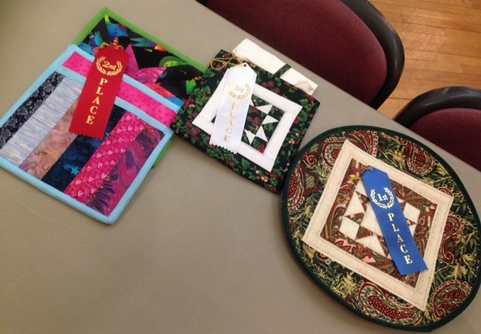

2018 Quilt Show Committee: Martha Mazeika & Linda Reppucci
- Quilt Show 2018 – October 20 & 21 at the Saugus Senior Center, with set-up on Friday the 19th

- Quilt Show Committee Meeting
  - For all those interested in helping with the quilt show and/or leading a committee, please plan on attending the Quilt Show Committee Meeting:
    - Saturday, January 27th at 10am to 12 pm in the Community Room at the Saugus Public Library (295 Central Street in Saugus)

- Make a Raffle Quilt Block
  - Thank you, thank you, thank you!!!! The blocks that have been returned are beautiful!!! Most of the directions have been taken; thank you to members who are making the blocks! Don’t forget to return the finished blocks at the February meeting!
  - Samples showing how you can piece your block are posted on the HQG website under the Quilt Show tab. If you do not have the internet and need pictures of the sample blocks sent to you, please let Dottie or Martha know ASAP.
  - General directions for the blocks are also on the website. This was the sheet provided when you picked your color swatch.

Any questions, comments, or suggestions, don’t hesitate to contact us!

Martha & Linda, 2018 Quilt Show Chairs
Secretary Report: Dottie Macomber
Printed reports containing the full minutes of all previous meetings for the current guild year, both general membership and executive board, will be available for your perusal at monthly guild meetings.

**********************************************************************************************************************
As the Secretary, I am also in charge of the Sunshine and Shadow “committee”. If you know of any member who has suffered a serious illness or accident or has had a death in the family, please let me know so I can send them a card on behalf of the guild: 781-932-3602 or mcandmac@comcast.net

As to the “Sunshine” part of my job, if you have some good news that you would like to share with the guild, let me know that, too, so I can put it in the newsletter.

Many of you remember former member Jackie Gowell or know her daughter Kathy Miller, who has a long-arm quilting business and has quilted many a quilt for our members. Sadly, Kathy has informed us that her mother, Jackie, passed away on Tuesday, January 16th. I have sent a card on behalf of the guild but for those of you who would like to send your own personal note or card to Kathy, her address is 187 Winding Pond Road, Londonderry, NH 03053.

Member News: Dottie Macomber
Guild member Gail Dwyer will have 12 of her quilts displayed as part of the “Illuminations” project at Mass General Hospital. This is the third time her quilts have been shown at this venue. The exhibit will open the last week of February and run through May on the 7th floor of the Yawkey building in Boston. Way to go, Gail!

**********************************************************************************************************************

I would like to report that I have tried this tip submitted by Janet Dalis and I love it! Janet saw this tip on Pinterest: use clear flexible Nexcare medical tape and adhere it to the back of your rulers to prevent the rulers from slipping as you cut. I like this tape better than the various little dots and circles you can buy to do this job as they can cause a ruler to “rock” as you cut unless you stick a whole bunch of them on- and they’re expensive! This tape is also great for your older, well-loved and well-used Creative Grids rulers when their built-in grippy circles have worn down and no longer grip.

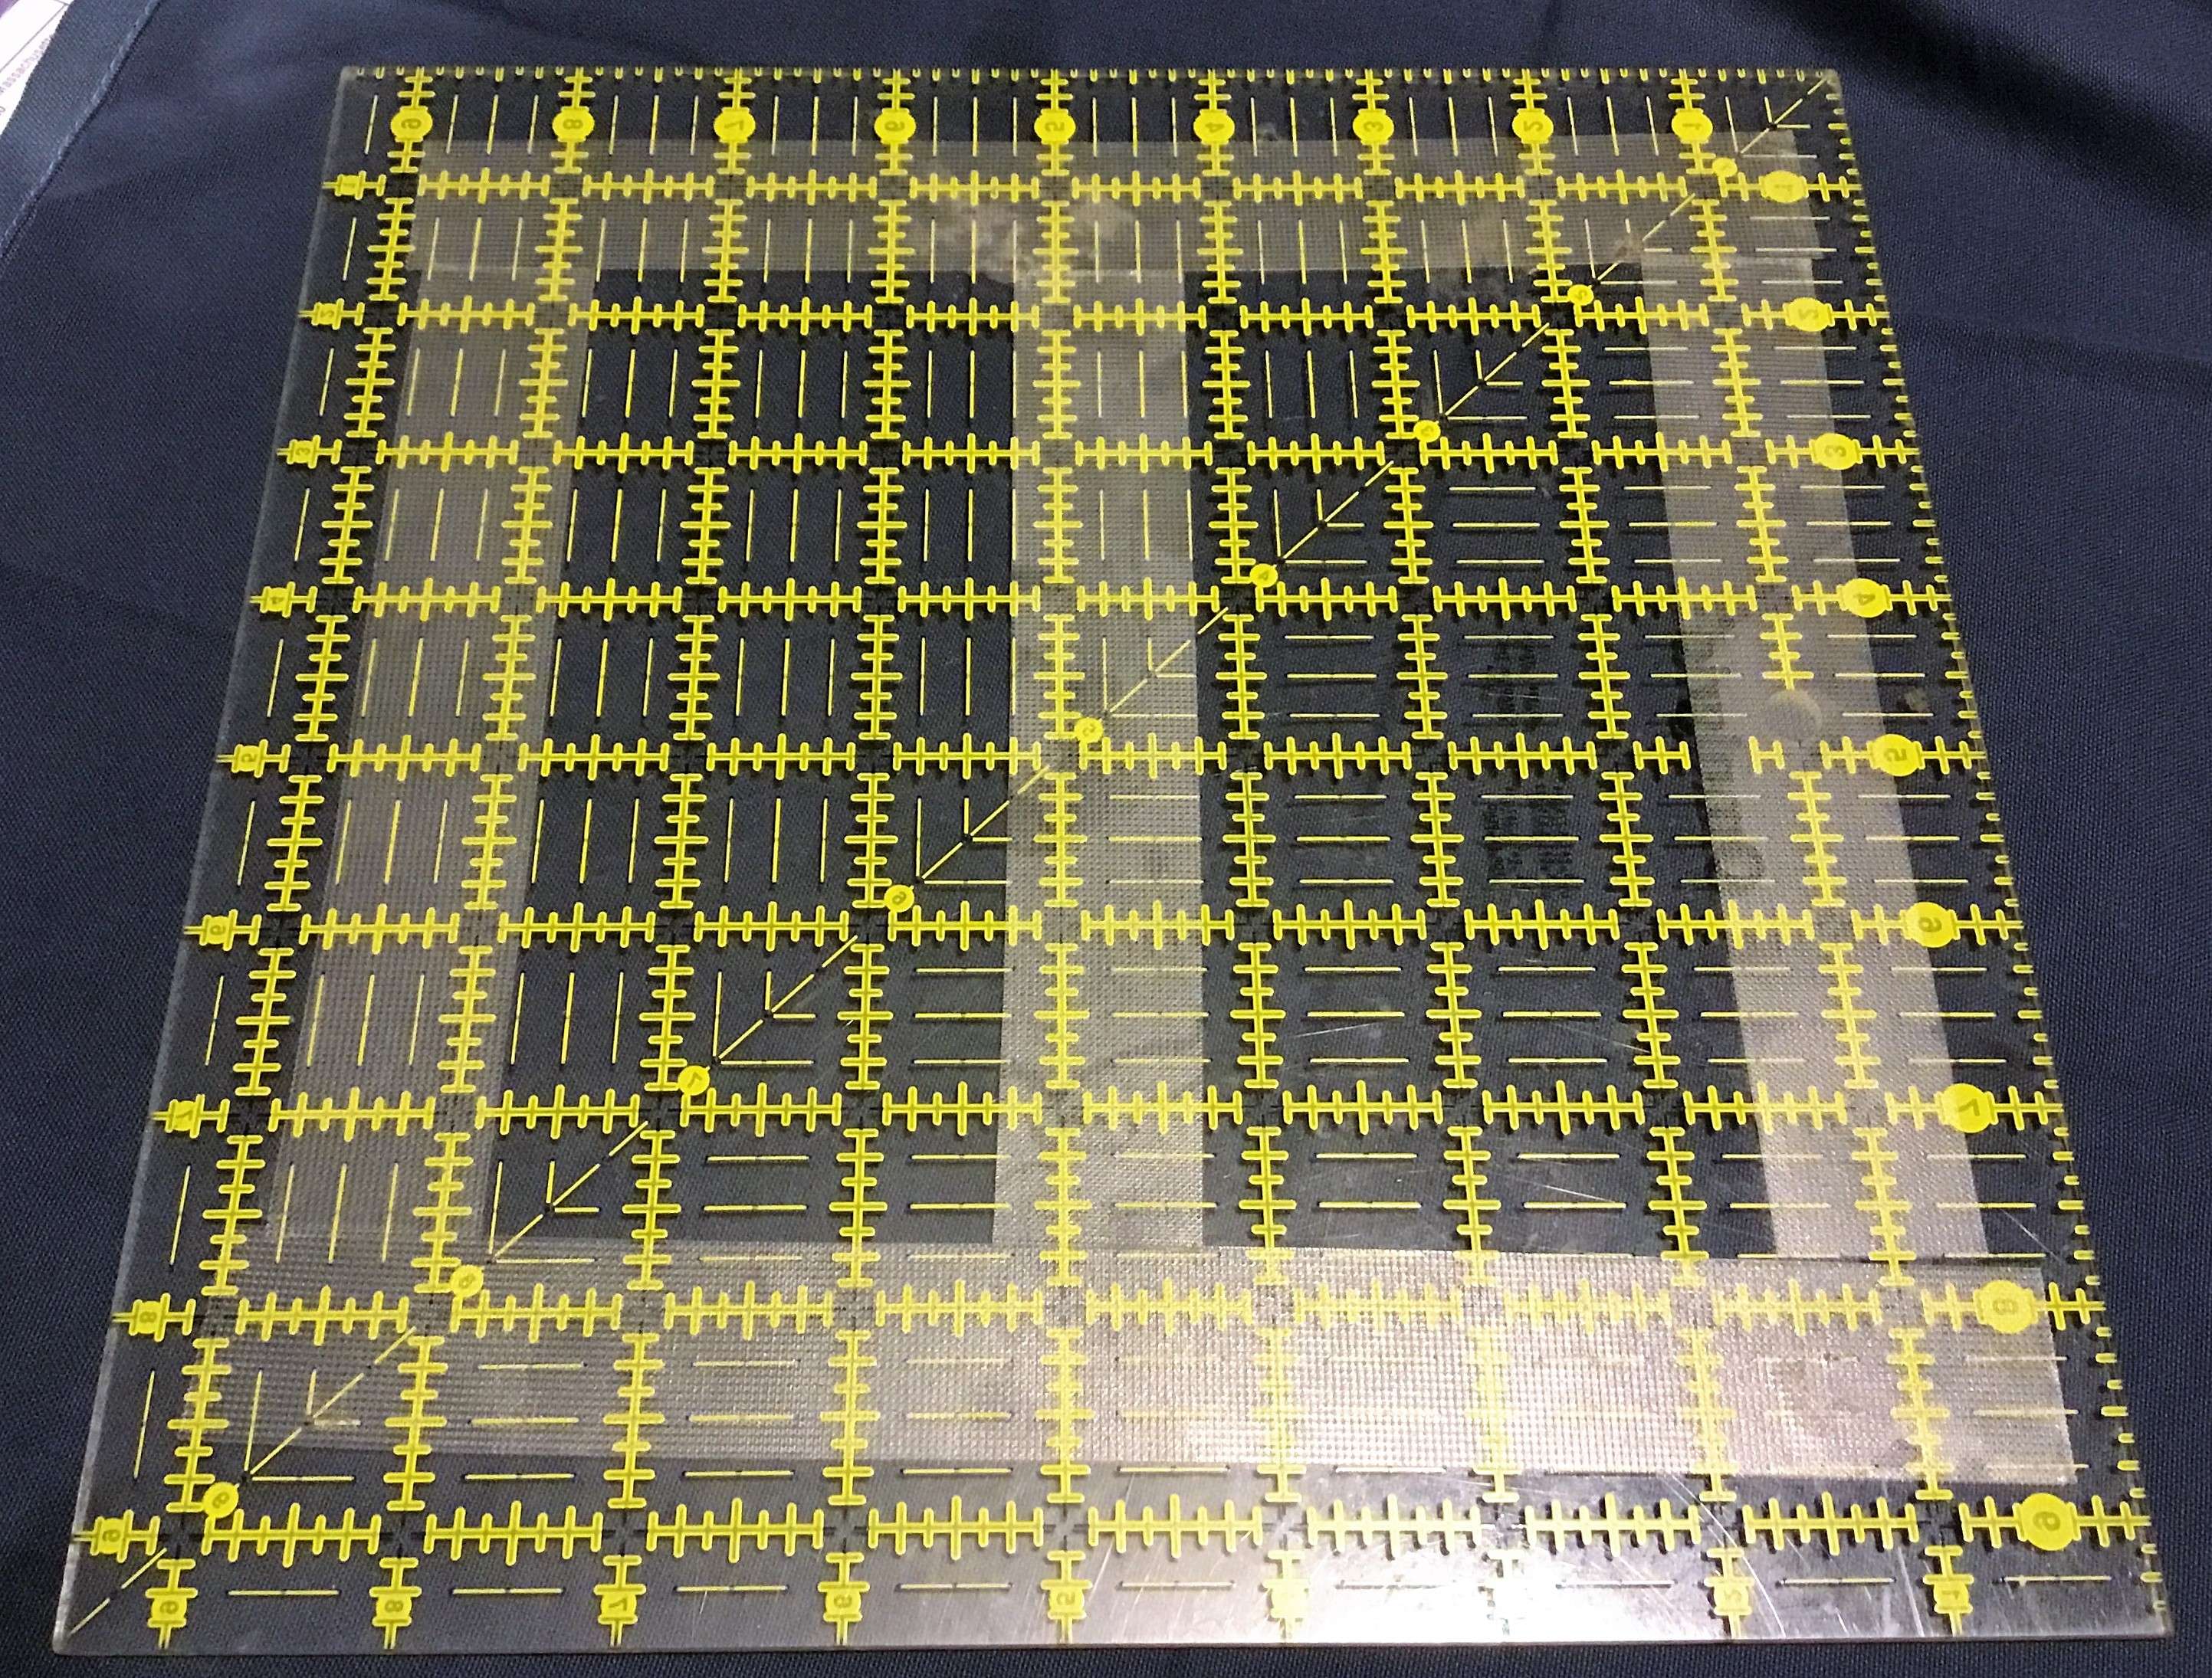

*********************************************************************************************************************
If anyone submits quilts to shows or fairs, or if you have any other quilty accomplishments to report, please send the news (with photos if possible) to me, Dottie Macomber, at mcandmac@comcast.net or 9 Fletcher Rd, Woburn, MA 01801. Let us celebrate your quilty news with you!

News Around the Guilds and at the New England Quilt Museum
The New England Quilt Museum has expanded its winter schedule and is open Tuesday through Saturday, 10-4 each day. Remember, you can park on Saturdays for free in the lot behind the museum; access this lot from Middle Street across from the Life Alive! restaurant.

The current exhibit in the main gallery is the 13th Quilt Nihon exhibit from Tokyo, “Quilts Japan”, and it’s an amazing collection of Japanese quilts. As usual, many Japanese quilters still do fine handquilting; and the details, composition, colors and fabrics used in the quilts are simply astounding. This is an exhibit you will not want to miss.

The classroom gallery contains an exhibit of the handquilted works of New Hampshire doctor and quilter, Gladi Porsche. This, too, is an amazing exhibit and one you will want to see.

Upcoming special events at the Museum include the following:

Thursday, Feb. 1st at 12:30 pm: Brown Bag Workshop (bring your lunch if you wish): Learn to make an origami Valentine in this fun and informal workshop. All supplies will be provided by NEQM.

Saturday, Mar. 3rd at 1:00 pm: Guest lecture by Allison Wilbur, “Japan: Tradition & Inspiration”. Japan is home to the world’s second largest quilting community and honors a rich history of textile traditions like shibori dyeing and sashiko stitching. This informative and entertaining lecture is offered by award-winning quilt artist, Allison Wilbur, who has lived and taught in Japan.

These two programs are free to museum members and are included in the price of admission for nonmembers.

Note: Allison is our guest speaker for our March 7th guild meeting, where she will be talking about quilting as a design element.

**********************************************************************************************************************

For those of you who are not attending our getaway weekend March 23rd-25th, don’t despair. You can still get a quilting “fix” by attending the Amoskeag Quilters Guild quilt show at Manchester Memorial High School in Manchester, NH, that Saturday and Sunday. See the Bulletin Board page of our website for more information.

Respectfully submitted,
Dottie Macomber, Secretary

