Hammersmith Quilters Guild Newsletter

www.hqgsaugus.org August 2018

***For This Meeting***
August 8, 2018

Program: “Ask the Experts”

Show 'n' Tell: No

Fat Quarter: Black & White

Refreshments: Gail Dwyer, Lauren Loughlin, Sally Nimblett, Barbara Martinson, Dottie Macomber, and Donna Cormier (water)

Creative Quiltworks: Clamshells

President’s Message: Martha Mazeika
[Editor’s note: At the June guild meeting, Martha mentioned that we are temporarily suspending the use of the “free stuff” table at meetings where folks can bring unwanted fabric, tools, etc. Too many items have been left on the table at the end of the night, making it necessary for someone to dispose of those things before the center is locked up for the night. Most times this has been Margie Berkowitch, and this is not fair to Margie or anyone else who has to clean up the unwanted stuff. If members are interested in restarting the “free stuff” table, we will revisit this issue in the fall.]

Greetings Quilters!!!

Quilters Home magazine published “The Quilters Home Bill of Rights” in the July/August 2007 issue. I want to share with you these rights over the next few months as stated in the article:

- A quilter has the right to have multiple projects in various stages of construction.
- A quilter has the right to start her/his block of the month quilt the week before it’s due, if ever.

The July meeting was fun to learn from our own colleagues. In August, we want you to bring projects to ask others their thoughts & ideas on challenges you are having. These meetings are really great to hear from each other. The conversations we have are the times I cherish as being part of the guild. I am looking forward to listening in August!

It is now coming to the last week of July. I hope you are all thinking of the projects you will be finishing for the quilt show and items for the Boutique. Have fun completing your creations!

Enjoy the rest of the summer!

Always here to listen, talk, discuss, and answer questions.
See you all on August 8th!!

Martha
(413)250-5449
marthamazeika@gmail.com

Reminder of schedule for monthly meetings:

6:30pm Hall opens
7:00pm-7:30pm Business meeting and Raffles
7:45pm-8:45pm Speaker/Other Program/Show ‘n’ Tell (when applicable)
8:45pm-9:00pm Good byes and Clean up
Please clean your tables, throw away trash, and pick up your snack containers at the end of the meeting.

Vice President’s Message: Gail Dwyer
Last chance to sign up for our EXCITING bus trip on Saturday, August 18, to the Mancuso World Quilt Show in Manchester, NH!! The bus will leave from the Saugus Senior Center at 8:30 a.m. and return at approximately 6:00 p.m.

Please bring your check or cash for final payment to the August 8th guild meeting. Price is $28, which includes show admission + water + snacks + camaraderie + fabulous quilts + lots of great vendors!

The bus trip is now open to all! Bring your friends, bring your husbands, bring anyone else who would have a good time at a quilt show!

Also, if you are interested, please bring a small handmade item to give as a prize on the bus. This is totally voluntary.

617-846-6551
Gaild516@aol.com

Treasurer’s Report: Carmen Arnone
After depositing membership dues received from Sally and accounting for checks written in July, our working balance is $13,518.56 .
Just a reminder: if you make purchases on behalf of the guild, please submit your receipt(s) to me at guild meetings. If possible, I will write a check and reimburse you then and there. If not, I will mail the check to you ASAP. Remember: no receipt, no reimbursement!

Membership: Sally Nimblett
There were fifty people signed in at our July meeting; this included one guest.

Dues for the 2018-2019 guild year were due by the June meeting. The dues are $25 for ages 70 and older, and $30 for all others. Please mail your dues ASAP to Sally Nimblett, 22 Pleasant Park Rd, Winthrop, MA 02152. Members who pay now will receive preprinted guild membership cards at the September meeting; these are good for discounts at shops who give guild discounts.

Just a reminder to everyone: be sure to sign in each month as you come in, or circle back to the front desk after you have dropped off your “stuff”. We like to keep attendance records because it helps us to know which programs/months are the most popular, and it give us an idea of how many handouts to prepare for meetings.

Refreshment Committee: Barbara Martinson & Kathy Connors
The following people will be bringing snacks for the August meeting: Gail Dwyer, Lauren Loughlin, Sally Nimblett, Dottie Macomber, Barbara Martinson & Donna Cormier (water).

Everyone: please see Barbara or find her sign-up sheet at the Snack table to sign up to bring a snack for an upcoming meeting. We welcome any snacks: baked good and other sweets, crackers & cheese, veggies, and fruit!

Program Committee: Joyce Rodenhiser, Janice Moore & Dottie Macomber
Our August 8th meeting will feature “Ask An Expert”! Yes, you are the experts!

Do you have a quilt or quilted item that you'd like to take to the rubbish barrel? STOP! Bring it to the August meeting instead! Ask the folks at your table how to fix it or add to it to make it better! If they have no ideas, ask at the next table and keep going until you find a solution that makes you happy! YOU HAVE PUT TIME AND MONEY AND EFFORT INTO YOUR WORK ! Let it not be wasted!

This will be a good social time and a help all at once! Have fun with this. Let's use the Brainstorming method which uses no negatives, accepts all answers and at last, chooses one that you like the best. (This way no one's feelings will be hurt!)

I have some orphan blocks which are pretty but I don't know what to do with them! I will bring them to look for suggestions. I made a bag of my own design but it surely needs help so I'll bring that as well! I also have a finished piece which I think is hopeless; let's see what you think!! -Joyce

Our July meeting of member demos was very well received. Many members expressed a desire to have more such meetings. If you have a technique that you would be willing to demonstrate at a future meeting, please let Joyce, Janice or Dottie know. We would love to schedule such demo-meetings on a regular basis! While outside speakers and teachers are great, there is also much we can learn from each other! -Dottie

Charity Donations Committee: Gretchen Berkowitch, Sally Nimblett & Louise Nazzaro
Just a reminder: we are always collecting quilts (any size) and pillowcases to be donated to various charities, and this year we are also collecting doll quilts (sized approximately 16” x 20”) to be sold at our quilt show as a guild fund raiser. These can be brought to any guild meeting. If you have any questions about these items, contact any member of this committee.

New: You may start bringing in your Christmas and winter-themed pillowcases now. We will be stuffing these in November for distribution to kids through various social service agencies.

Creative Quiltworks Committee: Kristin Callahan, Ellen Moore & Lynda Galvin
The CQW project for August is Clamshells. Let’s see what you can make with piecing clamshells- or perhaps you can make a project by appliqueing clamshells, or by quilting a clamshell design with your stitching. Be creative!

There will be ribbons for 1st, 2nd and 3rd place. Everyone is eligible to vote for their favorite, so be sure to check out the completed projects and vote for your favorite.

Please pick up directions for each project from Ellen, Lynda or Kristin. The directions for all the projects for this guild year are also available on the website under the Newsletter tab.

There was only one entrant for the July Origami Fabric Fun so no winner was chosen for July.

2018 Quilt Show Committee: Martha Mazeika & Linda Reppucci, co-chairs
Quilt Show Committee
The next Quilt Show Committee Meeting will be held on Thursday, August 2nd, 5:30 pm-7:30 pm at the Saugus Public Library. If you are a committee chair and cannot make it, please send an update for your area to Linda or Martha.

Raffle Quilt
Raffle tickets and photos of the quilt are available at meetings from now through the show. Please pick up your tickets from Dottie. Each member is expected to sell 2 books of tickets. (Tickets are $1 each or a book of 6 tickets for $5.) If you don’t want to sell them, buy them yourself; maybe you’ll win the quilt! Of course, you can always take more than two books! There is a prize of a kit for a great fall wallhanging from ShabbyFabrics.com for the person selling the most tickets, and there are smaller Patch-abilities wall hanging kits for the members selling the second- and third-most tickets! Turn in your ticket stubs and money (cash or check made out to HQG) to Dottie.

Martha, Carmen and Dottie spent the day on July 14th at the New England Quilt Museum in Lowell selling raffle tickets. We took in $60 which, while not the high number we were hoping for, was $60 more than we had before that day! Members will also be selling tickets at the Saugus Founder’s Day on Saturday, September 8th; if you would like to help with that, pleases see Holly. (An incentive: members selling tickets at an outside event have a proportionate number of the ticket sales credited to them to count toward the above-mentioned prizes!)

Registration forms are now available; pick them up from Holly Petersen. As has been past practice, no forms will be mailed; you must pick them up in person. We will have them available at the August meeting. Keep in mind that your completed forms are DUE AT THE SEPTEMBER MEETING in order to give us enough time to prepare labels for the show. If you are not going to be at the August meeting, please ask a friend to pick up a registration pack for you. Only the quilts listed on forms will be accepted- no substitutions- so think now about what quilts you want to enter. As in past years, each member can enter one quilt in each of the following categories: Large (bed-sized from twin to king); Small (wallhanging, baby quilt, lap quilt- smaller than a twin bed); Other (table runners, quilted clothing, quilted ornaments, etc.); Child age 12 or under sponsored by a guild member; and Creative Quiltworks Challenge (this year the challenge is Polaroid block quilts). If you want to enter more than one item in a category, trade forms with someone who does not need that entry form. Holly also has extra forms turned in by members who will not be using them, so you can ask Holly if she has an extra form for the category you want. Turn in your completed forms to Holly or Dottie.

Volunteering
Because the revenues generated by the quilt show benefit everyone in the guild, we ask that each of you volunteers for at least 2 hours either during the show, during set-up on Friday October 19, or during take-down after the show on Sunday October 21. Holly Petersen is the volunteer coordinator. Please sign up for your shift with Holly; she can let you know where and when we need help. In addition to doing your part for the guild, volunteering gets you free admission to our show! (Otherwise, admission is $6.00.)

If you are volunteering at the show, please wear your guild name badge. The committee used to provide name badges for volunteers but is no longer doing that. Wearing your name badge identifies you to our visitors as a person who can answer questions or provide information.

Raffle Baskets
Don’t forget to start working on a raffle basket for the show. Get together with several friends to design and fill a themed basket for us to raffle. See Adrienne Nolan or Martha Mazeika to register your idea (baby, wine, spa, game night, Italian dinner, barbeque, lottery tickets, etc.). We will need your baskets filled with items in the fall.

Adrienne also needs LOTS of good quality fat quarters to make up our huge and hugely-popular raffle basket FULL of fat quarters! Any colors, solids or prints, any types of 100% cotton quilt-shop quality FQs are welcome. (Just check to make sure you aren’t donating one that you cut that little piece out of when you needed the perfect little piece for an applique project!)

Boutique
Bev McGrath has forms for the boutique, including guidelines/instructions and an inventory sheet. The forms are also available on our website under “Quilt Show” for you to print out yourself. There is no deadline for passing in your inventory sheets; just bring them with your boutique items on Friday, October 19, on quilt show set-up day. Let Bev know now if you will be selling boutique items so she can assign a number to you for your tags and to put on your inventory sheets. As in the past, when an item sells, you get 80% of the selling price and the guild gets 20%, a Win-Win for everyone! You have the rest of the summer, September, and much of October to create great handmade items for the boutique. Participation is encouraged to make our boutique a success!

Secretary Report: Dottie Macomber
Printed reports containing the full minutes of all previous meetings for the current guild year, both general membership and executive board, will be available for your perusal at monthly guild meetings.

**********************************************************************************************************************
As the Secretary, I am in charge of the Sunshine and Shadow “committee”. If you know of any member who has suffered a serious illness or accident or has had a death in the family, please let me know so I can send them a card on behalf of the guild: 781-932-3602 or mcandmac@comcast.net

Ruth Ruggeri has been hospitalized after suffering a massive stroke. We are keeping her in our thoughts as she recovers. She would appreciate receiving cards, which may be sent to her home address: 2 Lenox Ave, Saugus, MA 01906.

Member News: Dottie Macomber
As always, if anyone submits quilts to shows or fairs, or if you have any other quilty accomplishments to report, please send the information (with photos if possible) to me, Dottie Macomber, at mcandmac@comcast.net or 9 Fletcher Rd, Woburn, MA 01801. Let us celebrate your quilty news with you!

Congratulations to Nita Penfold, who has had an art quilt accepted into the “Something Boro’d Something Blue” juried show at the Brush Gallery in Lowell. This exhibit of quilts influenced by Japanese boro traditions and techniques of layered and stitched patchwork, runs from August 4 to September 15th, 256 Lowell St. (GPS: 304 Dutton St.) There is a demonstration on Thursday August 2nd at 6:00 PM, and an opening reception on Saturday, August 11th from 2:00-4:00 PM. The Brush Gallery is supported by the Lowell National Historical Park; admission to the gallery is free. For more information, see www.thebrush.org

Rosie Graham called my attention to a posting by quilt instructor and designer Kimberly Einmo about the Vermont Quilt Festival. Janome also shared the post on Facebook. This is a photo recap of the festival. Follow the link below and scroll about 2/3 of the way down to see Janet Dalis’ “Splendid Sampler” mentioned by Kimberly as a “true masterpiece”!

https://www.kimberlyeinmo.com/vermont-quilt-festival-2018-a-photo-recap

Congratulations to Gretchen Berkowitch, whose quilt won a 3rd place ribbon at the Vermont Quilt Festival! Below are Gretchen, her quilt, and guild member Kristin Callahan.

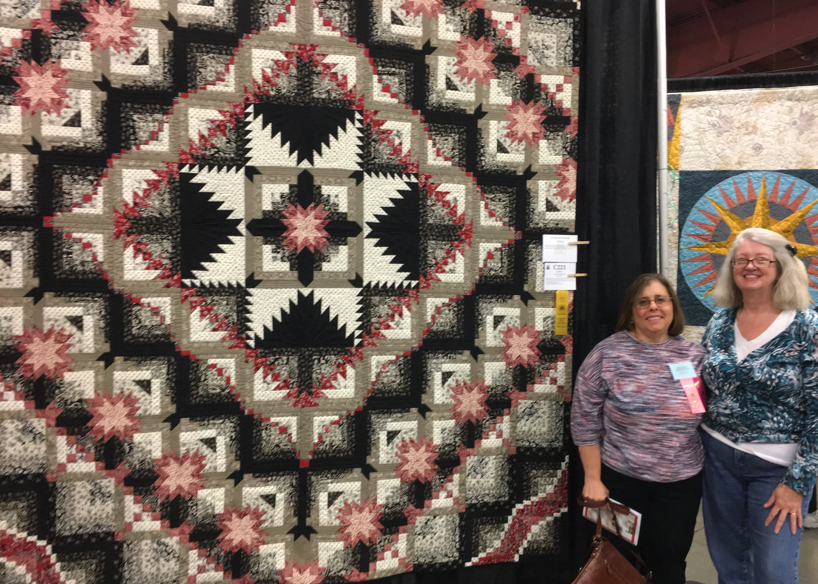

News Around the Guilds and at the New England Quilt Museum
The museum is now open for its summer hours, Tuesday through Sunday, from 10:00 to 4:00 each day. Remember, you can park on weekends for free in the lot behind the museum; access this lot from Middle Street across from the Life Alive! restaurant.

*********************************************************************************************************************
The museum library accepts donations of quilting magazines that are no older than 10 years as well as quilting books (not general sewing or crafting books) that are no older than 20 years. Thank you for thinking of the museum when you are cleaning out your book and magazine stash and for adhering to these donation guidelines. Please be sure that any magazines you donate do not have pages torn out.

*********************************************************************************************************************
Be sure to check our website under the Bulletin Board tab; there are many quilt shows, both local and regional, this summer and fall. As I learn of them, I will post them on our website.

Respectfully submitted,
Dottie Macomber, Secretary

